Accel. PreCalc. Name _________________________
Writing Trig Functions Date ___________________ Per ____

For #1-6, write the equation of the following sine curves.

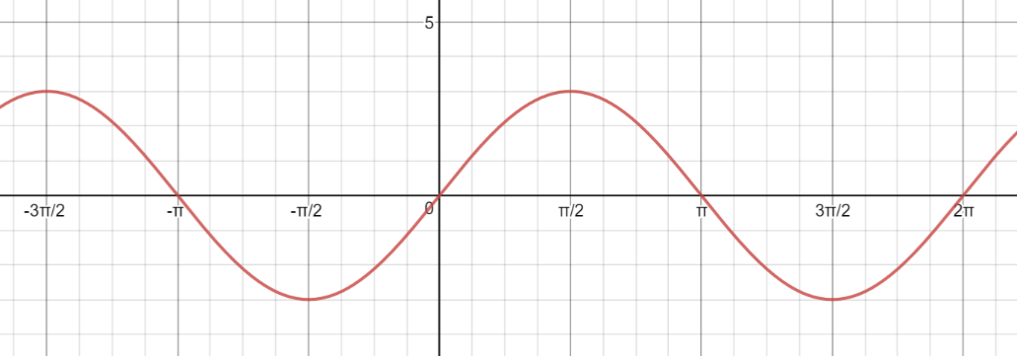
1.

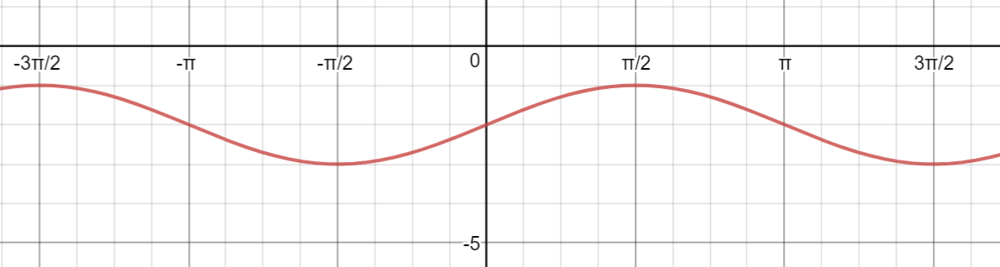
2.

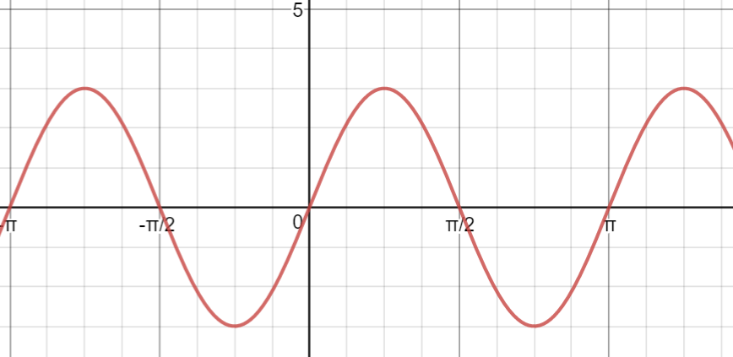
3.

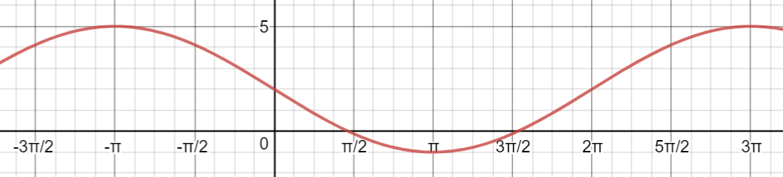
4.

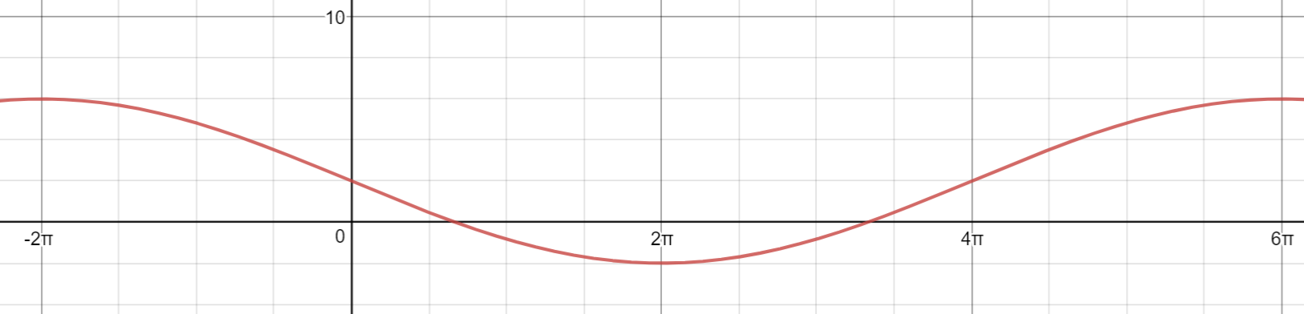
5.

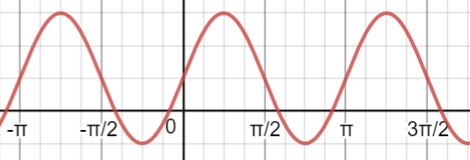
6.

For #7-10, write the equation of the following cosine curves.
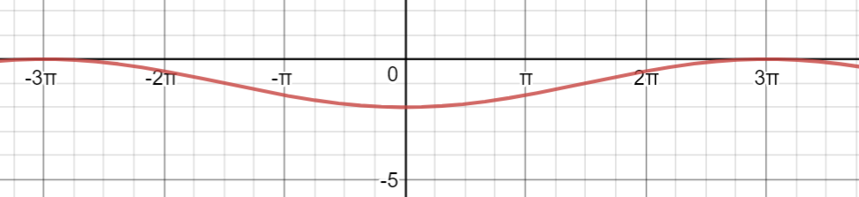
7.

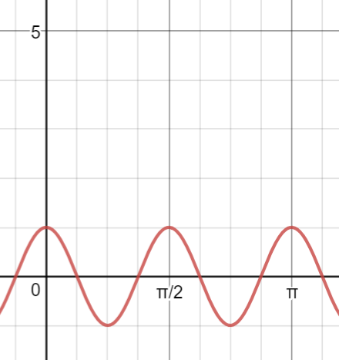
8.

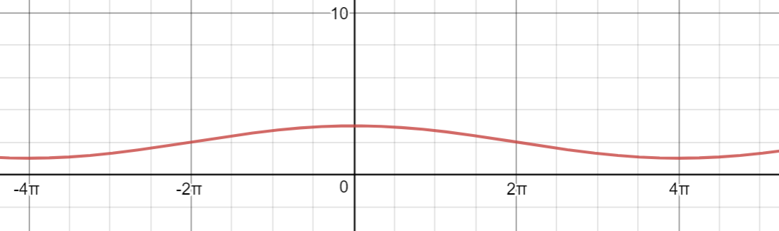
9.

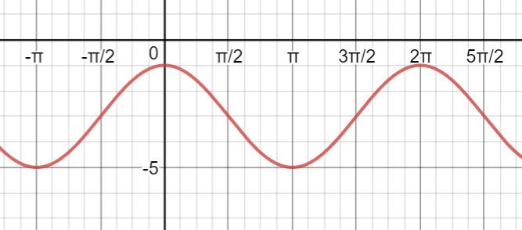
10.

For #11-13, write the equation of the following tangent functions.
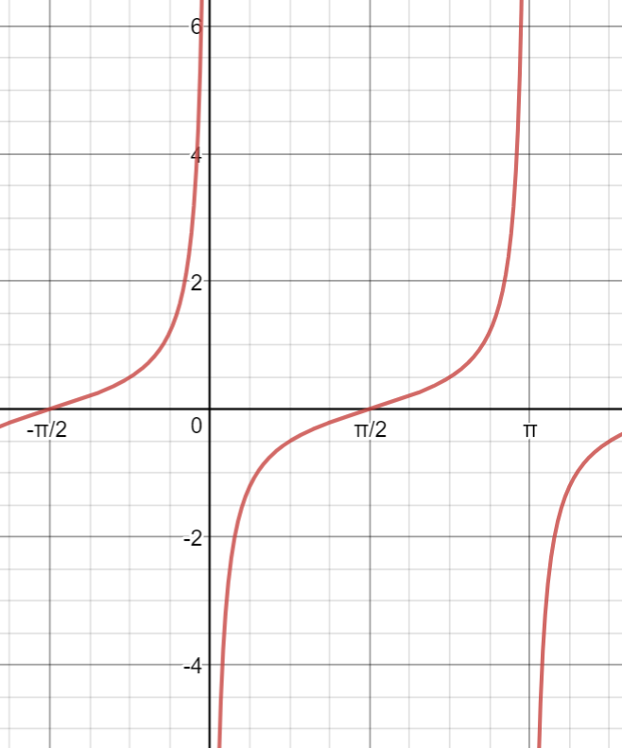
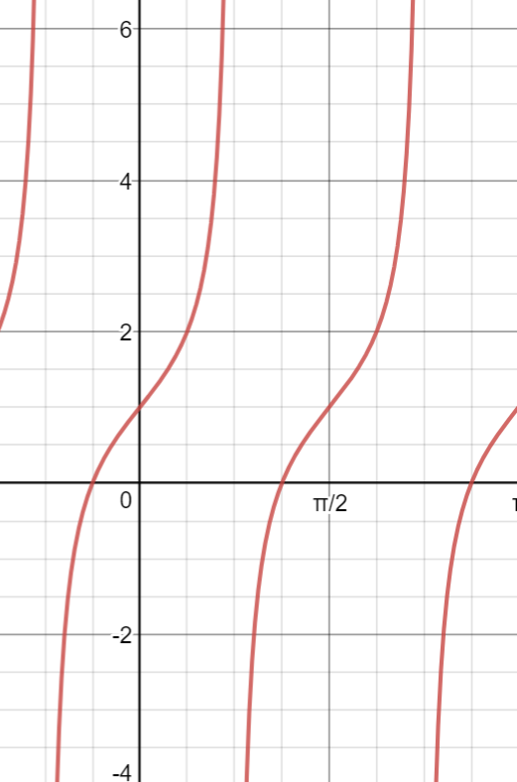
11. 12.

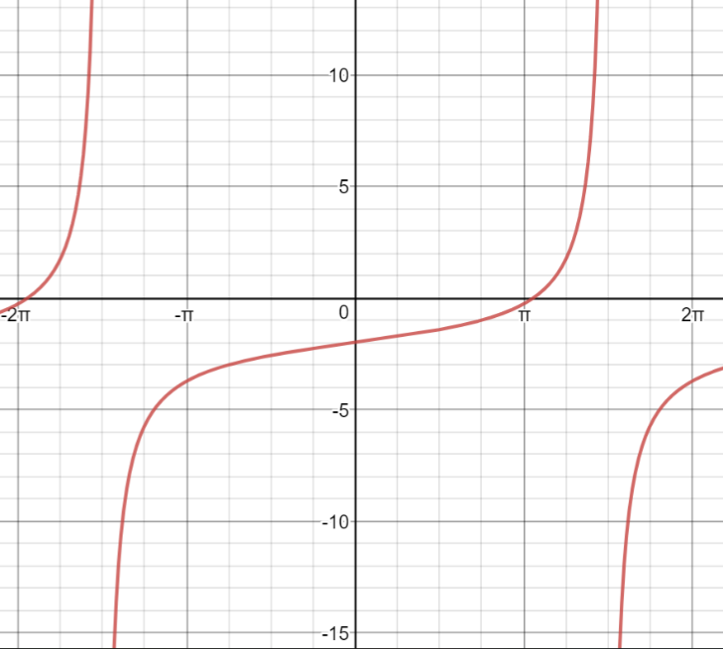
13.

Answer Key
1. $y=3\sin{x}$
2. $y=\sin{x-2}$
3. $y=3\sin{2x}$
4. $y=2-3\sin\left(\frac{1}{2}x\right)$
5. $y=-4\sin\left(\frac{1}{4}x\right)+2$
6. $y=2\sin{2x+1}$
7. $y=-\cos\left(\frac{1}{3}x\right)-1$
8. $y=\cos{4x}$
9. $y=\cos{\frac{1}{4}x+2}$
10. $y=2\cos{x-3}$
11. $y=4\tan{x+1}$
12. $y=\frac{1}{2}\tan\left(x+\frac{π}{2}\right)$
13. $y=\tan{\frac{1}{3}x-2}$

