Week of March 21, 2022
- Please complete the 2nd teacher check in. It is a quick Microsoft Form. This assignment must be completed by Friday, March 25 at 4:00PM.
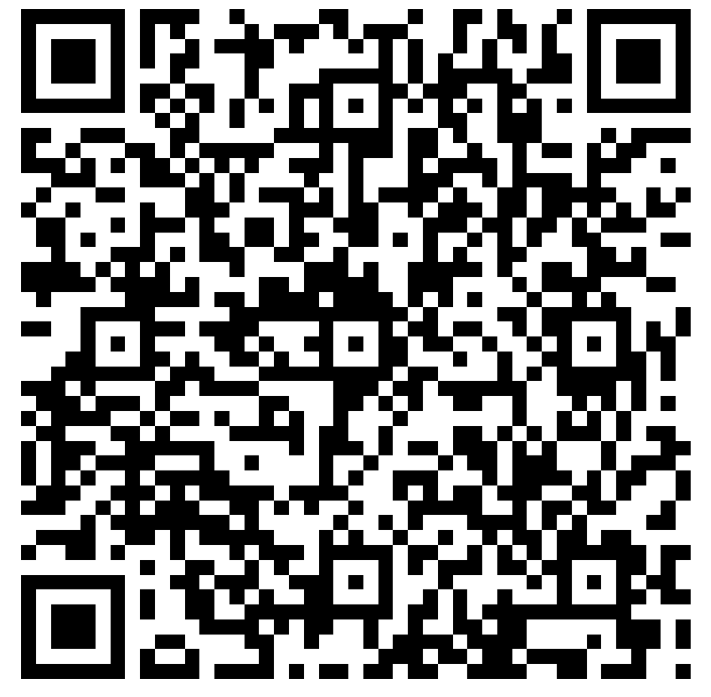
- Please remember to upload your timesheets once you reach the 40 hour mark.

