Accelerated Geometry Name ______________________

Volume: Pyramid, Cone, Sphere, Cylinder Date _____________

|  |  |
| --- | --- |
| Volume of Pyramid | Volume of Cone |
|  |  |
| Volume of Cylinder | Volume of Sphere |
|  |  |

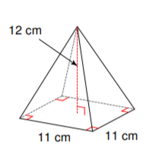Find the volume of each figure.

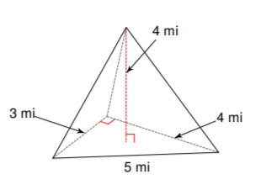

1. 2.

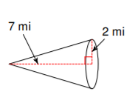

3. 4. A cone with radius 4m and height 12m.

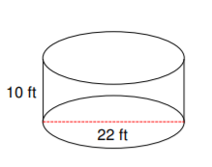

5. 6. A bowling ball with diameter of 8in.

7. Find the radius of the sphere whose volume is  .