Name _____________________________

Period _____ Date ________________

Throughout the review, assume that things that appear to be tangent really are tangent.

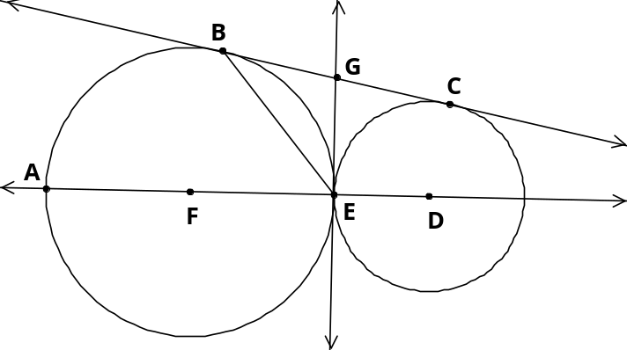
1. Vocab. Match each object to the word/phrase that best describes it.

common external tangent | chord (not a diameter) | minor arc
common internal tangent | diameter | secant | major arc
point of tangency | radius | center | semicircle

a. |  | ____________________ |  | f. |  | ____________________
b. |  | ____________________ |  | g. |  | ____________________
c. |  | ____________________ |  | h. |  | ____________________
d. |  | ____________________ |  | i. |  | ____________________
e. |  | ____________________ |  | j. |  | ____________________
 |  |  |  | k. |  | ____________________

2. Angle and Arc Measures. Find the requested measure.

 | a. |  | b. |  | c.
 | d. | m∠1 | e. | m∠1 | f. | m∠1
3. Angle and Arc Measures, continued. Find the value of x.

 | a. | 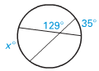 | b. | 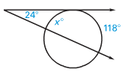 | c. | 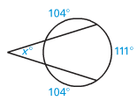
 |  | x = _____ |  | x = _____ |  | x = _____
 | d. | 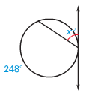 | e. | 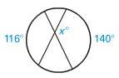 | f. | 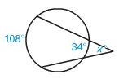
 |  | x = _____ |  | x = _____ |  | x = _____
 | g. | 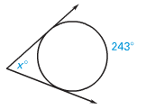 | h. | 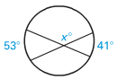 | i. | 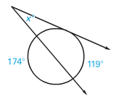
 |  | x = _____ |  | x = _____ |  | x = _____

4. Properties of Tangents. Find the value of x.

 | a. |  | b. |  | c.
 |  | x = _____ |  | x = _____ |  | x = _____
 | d. |  | e. |  | f. | 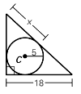
 |  | x = _____ |  | x = _____ |  | x = _____

5. Segment Lengths. Find the value of x.
 | a. | 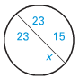 |  | b. | 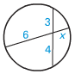 |  | c. | 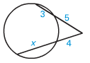
 |  | x = _____ |  |  | x = _____ |  |  | x = _____
 | d. |  |  | e. |  |  | f. | 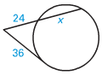
 |  | x = _____ |  |  | x = _____ |  |  | x = _____
6. Arc length and sector area.
a. Find exact arc length if radius of a circle and central angle are: r = 10; angle = 140⁰
b. Find the central angle measure of a circle if arc length is approximately 26.70 cm and radius is 6cm.
 |  | a. | b. | c. | d.
radius |  | 10 | 6 | 18
central angle |  | 140° |  |  | 130°
arc length | exact |  | N/A |  | N/A
arc length | approximate  (use π ≈ 3.14) |  | 26.70
area of sector | exact |  | N/A | 270 π | N/A
area of sector | approximate  (use π ≈ 3.14) |  |  |  | 10.21

7. Circle Puzzles.
 | 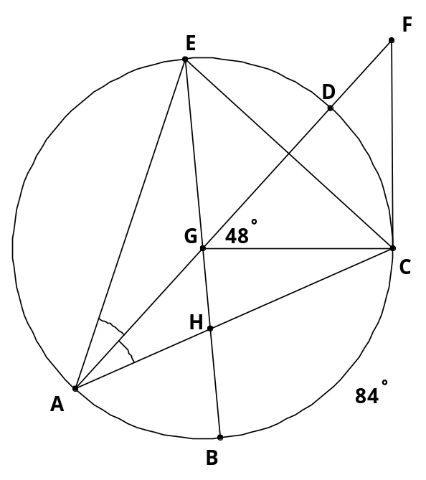 | Given: m∠DGC = 48°; 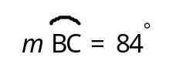  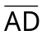 & 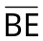 are diameters of P;  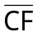 is tangent to P at C.
 |  | a. | 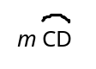 | ____________
 |  | b. | m∠F | ____________
 |  | c. | m∠FCG | ____________
 |  | d. | 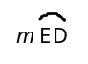 | ____________
 |  | e. | 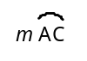 | ____________
 |  | f. | m∠GHC | ____________
 |  | g. | m∠BEC | ____________

8. Find the 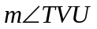.
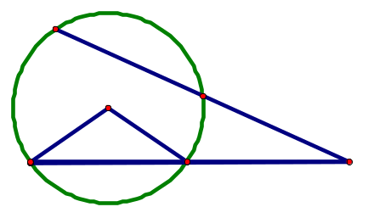
R
U
P
S
T
V
60°

108°

142°
24° x+2° 2x-17

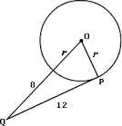
9. Solve for x.

10. Solve for r.

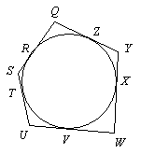

11. The circle is circumscribed by the pentagon as shown (not drawn to scale). If QZ = 14, YX = 8, XW = 7, UW = 11 and SU = 6, find the perimeter of the pentagon.

The quadrilateral is inscribed in the circle with angle A = 7x, angle B= 5y, angle C = 3x, and angle D= 3y. Solve for x and y.
A
B
C
D

12. x = __________

13. y = __________

1. | a. | diameter | f. | common int. tangent |  | 2. | a. | 58° | b. | 46° | c. | 123°
 | b. | secant | g. | minor arc |  |  | d. | 57.5° | e. | 52° | f. | 49°
 | c. | common ext. tangent | h. | point of tangency
 | d. | radius | i. | chord
 | e. | center | j. | major arc
 |  |  | k. | semicircle

3. | a. | 67° |  | b. | 70° |  | c. | 35° |  | 4. | a. | 20 |  | b. | 117 |  | c. | 5 |  | 5. | a. | 15 |  | b. | 2 |  | c. | 6
 | d. | 56° |  | e. | 128° |  | f. | 37° |  |  | d. | 24 |  | e. | -1, -2.5 |  | f. | 11.25 |  |  | d. | 5 |  | e. | 2 |  | f. | 30
 | g. | 63° |  | h. | 133° |  | i. | 26°

6. |  | a. | b. | c. | d.
radius |  | 10 | 6 | 18 | 3
central angle |  | 140° | 255° | 300° | 130°
arc length | exact | 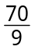π | N/A | 30 π | N/A
arc length | approx. | 24.42  or 24.43* | 26.70 | 94.20  or 94.24* | 6.80  or 6.81*
area of sector | exact | 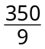π | N/A | 270 π | N/A
area of sector | approx. | 122.11 | 80.07  or 80.11* | 847.80  or 848.23* | 10.21
* Answers may vary slightly, depending on whether you used π ≈ 3.14 or the π button on your calculator.

7. Circle Puzzles.
 |  | a. | 48°
 |  | b. | 42°
 |  | c. | 90°
 |  | d. | 48°
 |  | e. | 132°
 |  | f. | 72°
 |  | g. | 42°

8. 29 degrees

9. 67

10. 5

11. 70

12. 18

13. 22.5

