Accelerated Geometry Name _____________________
Test Review: Volume, Cross Sections, Date ______________________
Rotations, Constructions

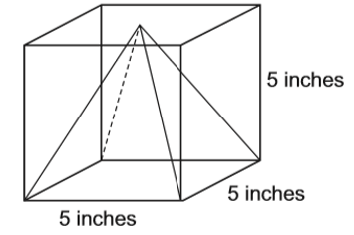
1. A square pyramid is packaged inside a box. The space inside the box around the pyramid is filled with protective foam. How many cubic inches of foam is needed to fill the space around the pyramid?

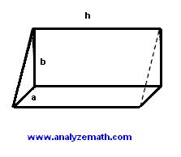
2. The triangular base of a prism is a right triangle of sides a and b = 2a. The height h of the prism is equal to 10 mm and its volume is equal to 40 mm³, find the lengths of the sides a and b of the triangle.

3. You and your friend are going to a movie. You both love popcorn and want to make sure you get the most. Which popcorn container will hold more?
Cylinder A: r = 4 h = 5 Cylinder B: r = 5 h = 3
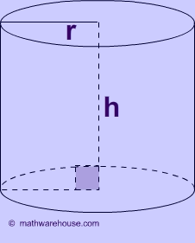

5. Find the volume of each oblique figure.
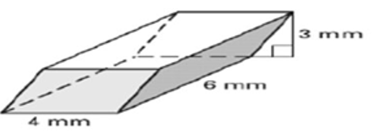
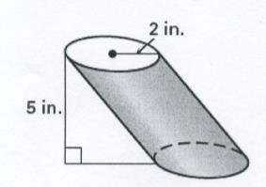

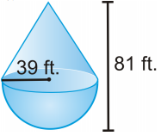
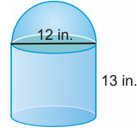
8. Find the volume. 9. Find the volume.

10.
A) Describe and sketch the figure formed by rotating the rectangle about the y-axis. What is the volume of the resulting figure?

B) Describe and sketch the figure formed by rotating the rectangle about the x-axis. What is the volume of the resulting figure?

11. Make sure you know the know the steps for the following constructions:
- Circumscribing a triangle
- Inscribing a circle
- Inscribing a quadrilateral
- Constructing a tangent from a point outside a circle
- Constructing a tangent passing through a point on a circle

