Accel. Precalculus Name:
Sine Curve Regression

Let’s examine the 1998-2000 surface water temperature record for Jack Bay on the lower
Patuxent River. These data are from the Maryland Department of Natural Resources.
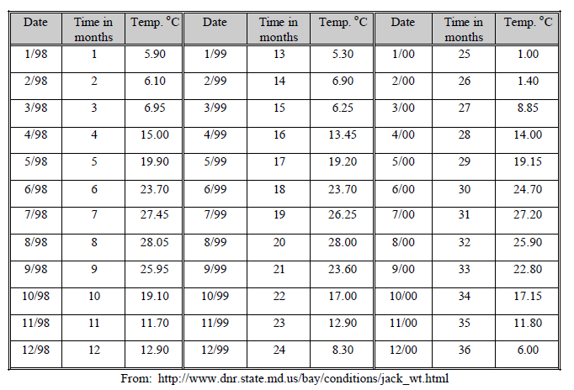
Create a table in Desmos and enter the data.

What type of relationship is found? Is there anything unusual about January and February of the
year 2000?

Sketch and describe the graph.

What is the range in temperature? This is the difference between the maximum and minimum
values.

What is the time interval between maxima (or minima)?

What type of mathematical function can model the cyclic nature of the data above?

Manually Fitting a Sine Function
Using graphical analysis, we can estimate the four parameters (a, b, c, and d) in the general
equation for a sine function. This will allow us to plot a sine curve through the data points.

1. Finding the midline (y = d) or y-axis shift
In a new line in Desmos, go to Functions and choose the Stats menu. Choose mean and complete the command as follows: mean( ). Enter the value in the blank below. In a new line, add the midline to your Desmos graph.

d = ___________

2. Estimate the period of the data
This is the time between adjacent maxima or adjacent minima. Convert the period, P, using the formula to angular frequency, b.

P = _________ b = 360/P = __________

3. Estimate the amplitude of the temperature
This is the difference between the maximum and minimum divided by two or the average
distance from the midline to maxima or minima.

a = ___________

4. Estimate the x-axis shift
This is the time along the midline from the y-axis to the point where the curve would cross the
midline.

c = ___________

5. In a new line in Desmos, type the general form (y=a sin (bx+c) + d) for a sinusoidal function and create sliders for a, b, c, and d. Set the sliders to the values you calculated above. If you need to adjust the scale of the sliders, click on the number at the end of the scale.

6. How well did your estimates fit the data? Do you need to make any adjustments to the values of a, b, c, and d? Record your final best-fit equation.

Fitting a Sine Function Using the Sine Regression

Begin by deleting everything EXCEPT your data table. In a new line in Desmos, type the following: . This is the command to calculate the regression equation (line of best fit) for the data. Record the values listed below. Make sure you are in degree mode under settings.

a = __________ b = __________ c = __________ d = __________

How well does the regression equation agree with your manual fit equation?

Use the regression equation to predict the temperature in April of 2001.

