Accel. Geometry Name ______________________

Segment Lengths in Circles Period _____ Date ___________

|  |  |
| --- | --- |
| **Theorem 1** | **Theorem 2** |
|  |  |
|  |  |

|  |  |
| --- | --- |
| **Example 1** | **Example 2** |
| Find the radius of the circle. | Find the value of *x*, given that *S* and *T* are points of tangency. |

**Example 3**: Write the equation of the line tangent to the given circle at the given point.

a) , (1,4) b) , (-8,1)

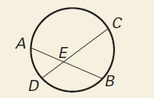Segments of Chords Theorem:

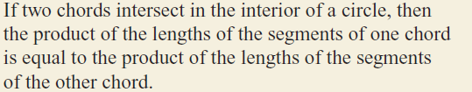

________________________

Segments of Secants Theorem:

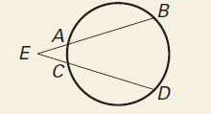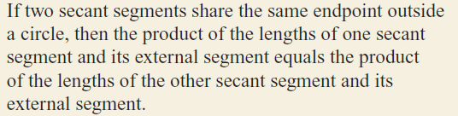

_________________________

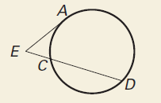Segments of Secants and Tangents Theorem:

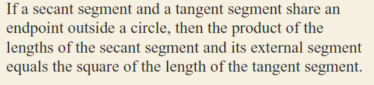

__________________________

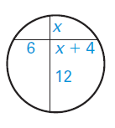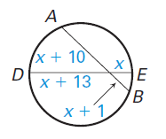Practice Problems:

1. 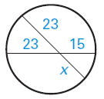 2. 3.

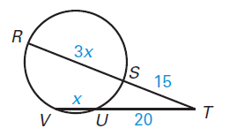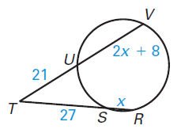

4. 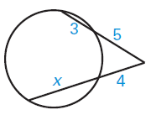 5. 6.

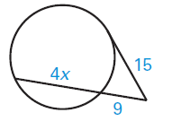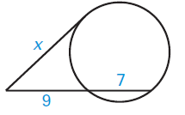7. 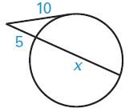 8. 9.