**Why Random Sampling?**

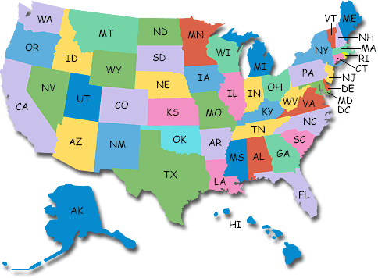

1. Use the map to choose a sample of 5 states to estimate the average (mean) land area.

2. Refer to the table of land areas. Find the mean land area for your sample.

3. Sketch the class dotplot of the mean land areas from step 2.

4. Now use your calculator to choose an SRS of 5 states. Find the mean land area for this sample.

5. Sketch the class dotplot of the mean land areas from step 4 right above your dotplot from step 3.

6. How do the class’s estimates using the two methods compare? Why might your answers from step 2 and step 4 differ? What advantage(s) does random sampling provide?