Accelerated Geometry Name______________________
Rotations of 2D Figures Date ______________________

Three dimensional figures can be created by ___________________ two dimensional figures.

Rotation:

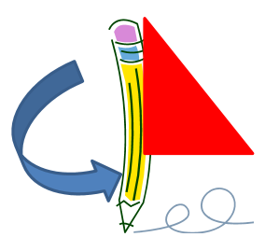
Rotation axis:

What 3D figure is generated by rotating the triangle in the given picture?

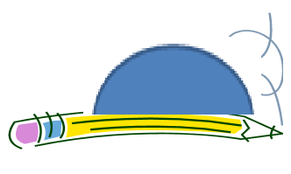
What about the hemisphere?

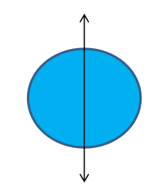
What about the square and circle?

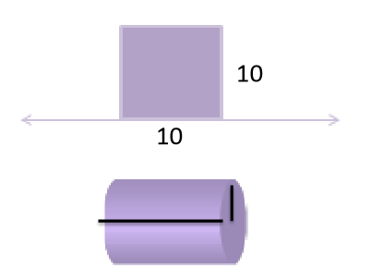
Problem 1: A square with area of 100 ${cm}^{2}$ is rotated to form a cylinder. What is the volume of the cylinder?

Problem 2: Given a cone with radius 6 ft and height 12 ft, find the area of the triangle formed by a perpendicular cross section down through the cone’s center.

