Factoring and Solving Quadratics – Accelerated Geometry/Algebra 2 Name__________________________________
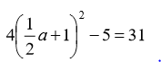
- Solve for a. 2. Solve for x 2( x - 7)² ₌ 8

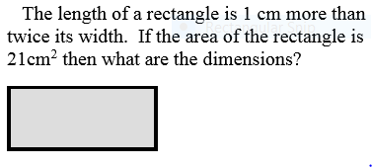
3. Solve for x 3( x + 4)² ₌ 15 4.

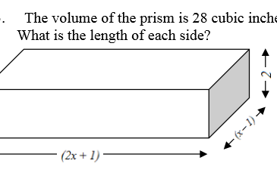
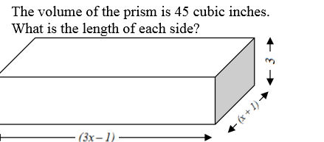
5. 6.

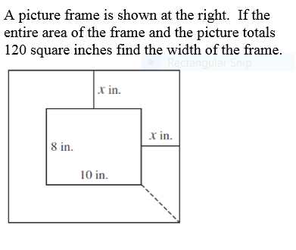
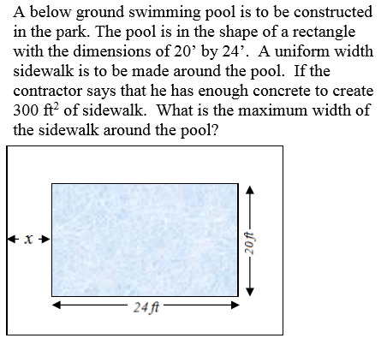
7. 8.

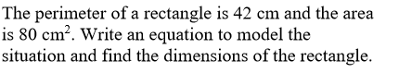
9. The product of two consecutive positive integers is 132. 10.
Write an equation to model the situation and find the two integers

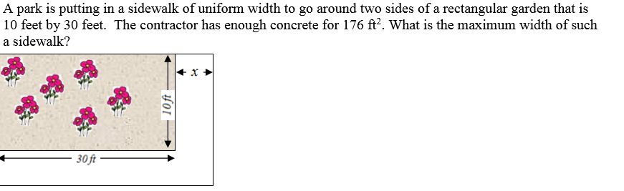
11.
12.
