Accel. Geometry Name _____________________________
Properties of Chords Period _____ Date ________________

Theorem: In the same circle or in congruent circles,
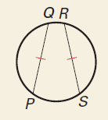
two minor arcs are congruent if and only if

____________________________________

__________________________________________

__________________________________________

Theorem: If one chord is a perpendicular bisector of another chord,
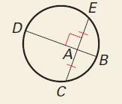
______________________________________________

______________________________________________

Theorem: If a diameter of a circle is perpendicular to a chord,
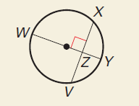
____________________________________________

____________________________________________

Theorem: In the same circle, or in congruent circles,
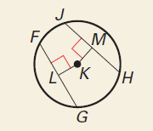
two chords are congruent if and only if

__________________________________________

__________________________________________

Find the chord length or arc measure:
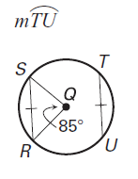
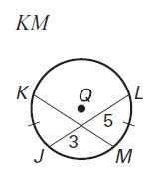
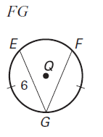
1. 2. 3.

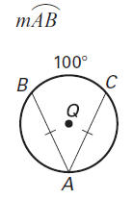
4.

Find the given measure:

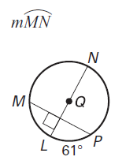
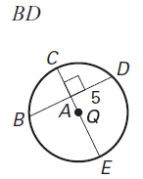
5. 6.

Find the given measure:

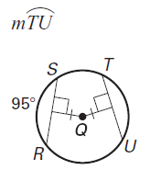
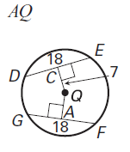
7. 8.

Find the value of x:

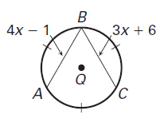
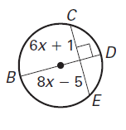
9. 10.

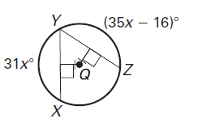
11.

