Accelerated Geometry Name _______________________

Triangle Proofs in the Coord. Plane Date _______________________

Using what we know:

* We can use ________________ to show parallel and/or perpendicular lines.
  + Parallel lines have the ___________ slope.
  + Perpendicular lines have slopes that are ___________________________.
* We can use ________________ to show that lines bisect each other.
* We can use ________________ to show that line segments are equal.

There are two methods that may be used to show that a triangle is a **RIGHT TRIANGLE**:

Method 1:

Method 2:

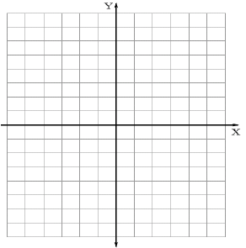**Example 1**: Show that the figure with coordinates A(1, 1), B(4, 5) and C(4, 1) is a right triangle.

**Example 2:** Show that the triangle with vertices A(4, -1), B(5, 6) and C(1, 3) is an isosceles right triangle.

**Example 3:** Prove that A(1, 1), B(4, 4) and C(6, 2) are the vertices of a right triangle.



Accelerated Geometry Name ______________________

Proving Right Triangles Practice Date _______________________

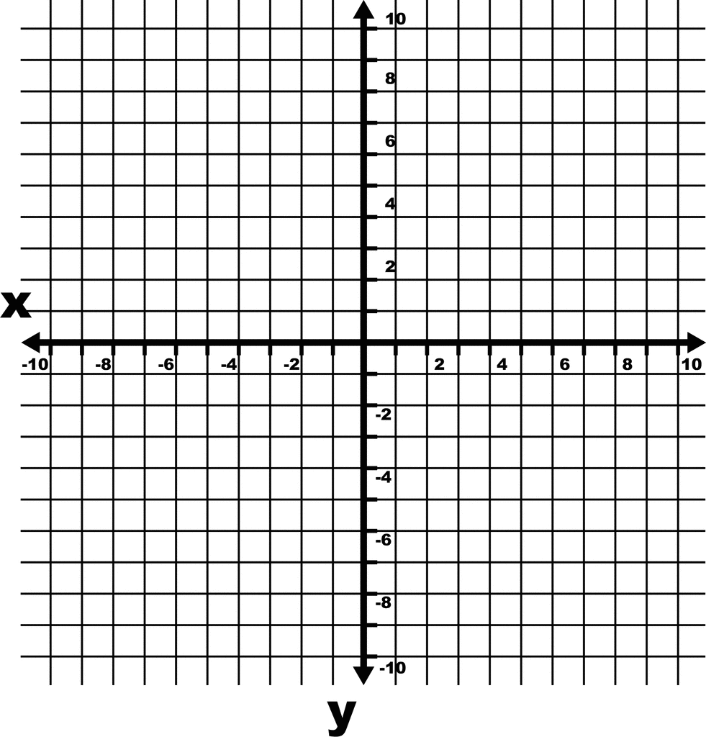1. Triangle QRS has vertices Q(0, 0), R(4, 8) and S(6, 2). Prove using coordinate geometry that QRS is an isosceles triangle.

2. Triangle ABC has vertices at A(-1, 2), B(-4, 6) and C(7, 8). Prove that ABC is a right triangle.

3. Triangle ELI has vertices at E(3, -1), L(0, -1) and I(0, 2). Prove ELI is an isosceles right triangle.

Properties of Quadrilaterals

Place an X in the box if the quadrilateral has the given property.

|  |  |  |  |  |  |
| --- | --- | --- | --- | --- | --- |
|  | **Parallelogram** | **Rhombus** | **Rectangle** | **Square** | **Kite** |
| **Both pairs of opposite sides are parallel** |  |  |  |  |  |
| **Exactly one pair of opposite sides are parallel** |  |  |  |  |  |
| **All four sides are congruent** |  |  |  |  |  |
| **Both pairs of opposite sides are congruent** |  |  |  |  |  |
| **Exactly one pair of opposite sides are congruent** |  |  |  |  |  |
| **Two pairs of consecutive sides are congruent** |  |  |  |  |  |
| **Has four right angles** |  |  |  |  |  |
| **Consecutive angles are supplementary** |  |  |  |  |  |
| **Both pairs of opposite angles are congruent** |  |  |  |  |  |
| **Exactly one pair of opposite angles are congruent** |  |  |  |  |  |
| **Diagonals are perpendicular** |  |  |  |  |  |
| **Diagonals are congruent** |  |  |  |  |  |
| **Diagonals bisect each other** |  |  |  |  |  |
| **Exactly one diagonal bisects the other** |  |  |  |  |  |

|  |  |
| --- | --- |
|  | Sketch a diagram labeling all the properties of each figure. |
| Parallelogram |  |
| Rhombus |  |
| Rectangle |  |
|  | Sketch a diagram labeling all the properties of each figure. |
| Square |  |
| Kite | * Two pairs of consecutive sides are congruent. * Diagonals are perpendicular. * Exactly one diagonal bisects the other. * Exactly one pair of opposite angles are congruent. |

Answer each of the following with ALWAYS, SOMETIMES, or NEVER.

1. A rhombus is a square.

2. A square is a rhombus.

3. A rectangle is a rhombus.

4. A parallelogram is a rectangle.

5. A rectangle is a parallelogram.

6. A kite is a quadrilateral.

7. A kite is a parallelogram.

Accelerated Geometry Name _________________________

Quad. Proofs in Coord. Plane Date ___________________________

There are four methods that may be used to show that a quadrilateral is a **PARALLELOGRAM**:

Method 1:

Method 2:

Method 3:

Method 4:

**Example 1:** Use coordinate geometry to prove that the given vertices form a parallelogram:

R(3, 2), S(6, 2), T(0, -2), U(-3, -2)

**Example 2:** Prove that the following quadrilateral is a parallelogram.

L(-3, 1), E(2, 6), A(9, 5), P(4, 0)

**Example 3:**

1. Plot the points E(1, 2), F(2, 5), G(5, 6), H(4, 3)
2. Draw the diagonals of EFGH. Find the coordinates of the midpoint of each diagonal. What do you notice?
3. Find the slopes of the diagonals. What do you notice?
4. Based on your answers to parts b and c, what type of quadrilateral is figure EFGH?

Accelerated Geometry Name ___________________________

Quad. Proofs Practice Date ____________________________

You are told that ABCD is a parallelogram. Use the properties of quadrilaterals, along with slope, midpoint and distance, to determine if ABCD is a rectangle, rhombus, square, or just a parallelogram. Justify your answer (show your work).

|  |  |
| --- | --- |
| 1. A(5, 2), B(2, 5), C(-1, 2), D(2, -1)  Image result for coordinate grid | 2. A(-4, 3), B(1, 2), C(2, -3), D(-3, -2)  Image result for coordinate grid |
| 3. A(-1, 4), B(-3, 2), C(2, -3), D(4, -1)  Image result for coordinate grid | 4. A(1, 1), B(2, 4), C(5, 6), D(4, 3)  Image result for coordinate grid |

5. Plot points A(-3, -1), B(-1, 2), C(4, 2), D(2, -1).

1. Draw the diagonals of ABCD. Find the coordinates of the midpoint of each diagonal. What do you notice?

1. Find the slopes of the diagonals. What do you notice?
2. Based on your answers to parts b and c, what type of quadrilateral is figure ABCD?

6. Plot points P(4, 1), W(-2, 3), K(-6, -4), M(2, -5).

1. Draw the diagonals of PWKM. Find the coordinates of the midpoint of each diagonal. What do you notice?

1. Find the slopes of the diagonals. What do you notice?
2. Find the lengths of the diagonals. What do you notice?
3. Based on your answers to parts b and c, what type of quadrilateral is figure PWKM?

7. Plot points A(1, 0), B(-1, 2), and C(2, 5).

1. Find the coordinates of a 4th point, D, that would make ABCD a rectangle. Justify your answer (show your work).
2. Find the coordinates of a 4th point, D, that would make ABCD a parallelogram that is not also a rectangle. Justify your answer (show your work).

