Accelerated Geometry Name_______________________
Probability Vocab. & Venn Diagrams Date _______________________

Sample Space

Set

Element(s)

Examples
- Suppose the sample space is all numbers from 1 to 10. Write the sample space as a set.

- Let event A be all even numbers. Write the sample space for event A.

- When 2 dice are rolled, each die can land on any number from 1 to 6. The outcome (1, 1) represents the first die landing on 1 and the second die landing on 1. Fill in the rest of the sample space for rolling two dice.
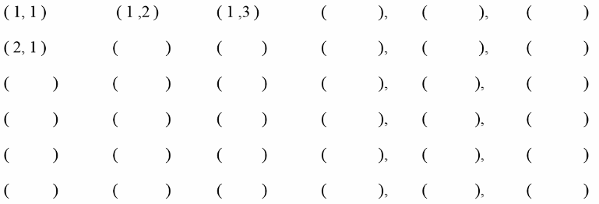

Use the sample space from part c above to answer the following questions.

1. Write the set of all outcomes where the first rolled number is the same as the second rolled number.

2. Write the set that contains all the elements that sum to 9.

3. What is the probability that the sum of the two rolled dice will be 9?

4. Determine the probability of having at least one of the two dice show an odd number.

Tree Diagrams

1. You have just graduated from college and have landed your dream job. You decide that you are going to purchase a new car. You are torn between a Honda, Toyota, or an Acura. Each of the makes comes in three colors: silver, red, or black, and two styles: coupe or sedan.

  - Make a tree diagram below for all possible outcomes. How many different cars are possible? _______________.

  - How many choices are a red coupe or a silver sedan? __________

  - You can’t make up your mind which car you want so you put every possibility in a hat and draw one. What is the probability that you draw a red coupe or a silver sedan?

Create-a-Sandwich Menu
Bread Meat Cheese
White Ham American
Wheat Turkey Swiss
2. Using the menu above, create a tree diagram of all possible sandwich combinations.

Compound Event:

Union:

Intersection:

Complement:

Examples
A) Let A = (1, 2, 3) and B = (3, 4, 5)

What is $A ∪B$? What is $A'$?

What is $A ∩B$? What is ${\left(A ∩B\right)}^{'}$ ?

B) Let A = (1, 3, 5, 7, 9) and B = (3, 4, 5, 6, 7)

What is $A ∪B$? What is $B'$?

What is $A ∩B$?

Venn Diagrams & Shading:

Examples

A) Twenty children made pictures in art class. 13 children used red crayons. Of those using red, 4 children used only red crayon to make their picture. 12 children used blue crayons. Draw a Venn diagram to represent this situation. How many children used both red and blue crayons to make their picture?

B) Forty two students took some type of summer school class. 28 students took science. 27 students took math. 26 students took both math and science.
How many students took science only?
How many students took math only?
How many students did not take math or science?

C) Suppose in a city there are 6 restaurants that serve pizza, 7 that serve tacos, 6 that serve hamburgers, 3 that serve pizza and hamburgers, 4 serve pizza and tacos, 4 serve tacos and hamburgers, and 2 serve all three types of food. How many restaurants are in the town?

