Name ____________________________

Period ____ Date ________________
Use simplest radical form where appropriate (no decimals!)
1. Find the vertex, focus, and directrix of each parabola, then graph the parabola.

 | a. | (x – 1) ² = 4(y – 4)  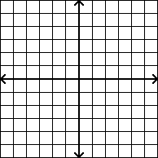 vertex:  focus:  directrix: | b. | x – 3 = -(y – 2) ²  vertex:  focus:  directrix:
 | c. | (y – 2) ² = 8(x – 1)  vertex:  focus:  directrix: | d. | -2(y – 3) = (x – 3) ²  vertex:  focus:  directrix:

2. Write the standard form equation of the parabola shown or described.

 | a. | 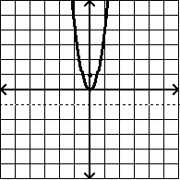 | b. | 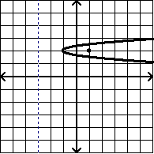
 | c. | Vertex (10, 0); Directrix x = 8 | d. | Vertex (0, 0); Focus (0, 6)

2, continued. Write the standard form equation of the parabola shown or described.
 | a. | Vertex (5, 2); directrix y = 1 | b. | Directrix x = 3; focus (1, 0)

3. Convert each equation to standard form, then find the parabola’s vertex, focus, & directrix.

 | a. | $$y^{2}+8x-2y-15=0$$  standard form:  vertex: focus: directrix: | b. | $$x^{2}+10x-6y+7=0$$  standard form:  vertex: focus: directrix:
 | c. | $$y^{2}-12y+4x+4=0$$  standard form:  vertex: focus: directrix: | d. | 8x ² + 16x + 4 – y = 0  standard form:  vertex: focus: directrix:

