Polar Graphing

**Circles:**

General Form: __________________________

1. 2.

|  |  |
| --- | --- |
|  | r |
| 0 |  |
|  |  |
|  |  |
|  |  |
|  |  |
|  |  |
|  |  |
|  |  |
|  |  |

|  |  |
| --- | --- |
|  | r |
| 0 |  |
|  |  |
|  |  |
|  |  |
|  |  |
|  |  |
|  |  |
|  |  |
|  |  |

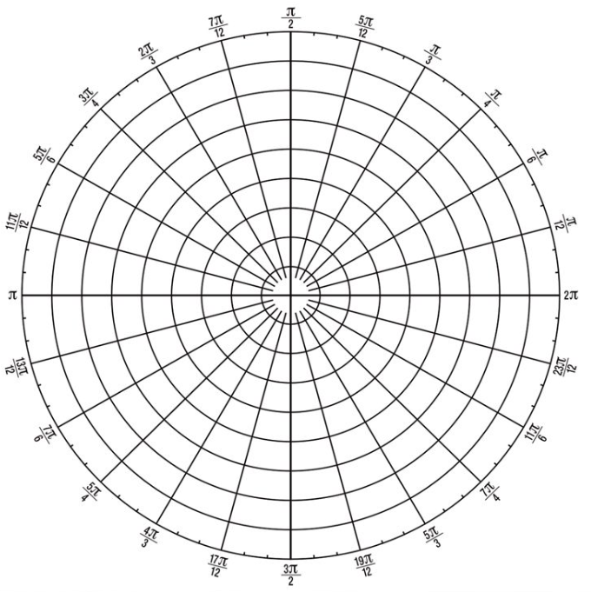



**Cardiods:**

General Form: ________________________________

1. 2.

|  |  |
| --- | --- |
|  | r |
| 0 |  |
|  |  |
|  |  |
|  |  |
|  |  |
|  |  |
|  |  |
|  |  |
|  |  |
|  |  |
|  |  |

|  |  |
| --- | --- |
|  | r |
| 0 |  |
|  |  |
|  |  |
|  |  |
|  |  |
|  |  |
|  |  |
|  |  |
|  |  |
|  |  |
|  |  |



**Limacon:**

General Form: _____________________________

1. 2.

|  |  |
| --- | --- |
|  | r |
| 0 |  |
|  |  |
|  |  |
|  |  |
|  |  |
|  |  |
|  |  |
|  |  |
|  |  |
|  |  |
|  |  |

|  |  |
| --- | --- |
|  | r |
| 0 |  |
|  |  |
|  |  |
|  |  |
|  |  |
|  |  |
|  |  |
|  |  |
|  |  |





3. 4.

|  |  |
| --- | --- |
|  | r |
| 0 |  |
|  |  |
|  |  |
|  |  |
|  |  |
|  |  |
|  |  |
|  |  |
|  |  |
|  |  |
|  |  |

|  |  |
| --- | --- |
|  | r |
| 0 |  |
|  |  |
|  |  |
|  |  |
|  |  |
|  |  |
|  |  |
|  |  |
|  |  |
|  |  |
|  |  |
|  |  |
|  |  |



**Rose Curves:**

General Form: ________________________________

1. 2.

|  |  |
| --- | --- |
|  | r |
| 0 |  |
|  |  |
|  |  |
|  |  |
|  |  |
|  |  |
|  |  |
|  |  |
|  |  |
|  |  |
|  |  |
|  |  |

|  |  |
| --- | --- |
|  | r |
|  |  |
|  |  |
|  |  |
|  |  |
|  |  |
|  |  |
|  |  |
|  |  |
|  |  |
|  |  |
|  |  |
|  |  |

