Accel. Geometry | Name: _____________________________
Partitioning Segments Practice | Period: ______ Date: _________________

1. | Find the number that is halfway between 12 and 40.
2. | Find the number between 12 and 40 that is three times as far from 12 as it is from 40.
3. | Given the points A (-2, 4) and B (7, -2), find the coordinates of the point P that partitions  the directed line segment $\overset{⃑}{\text{AB} }$ in a ratio of 1 : 2.
4. | Given the points A (-2, 4) and B (7, -2), find the coordinates of the point P that partitions  the directed line segment $\overset{⃑}{\text{AB} }$$\overset{⃑}{\text{BA} }$ in a ratio of 1 : 2.  (This is the same as the previous question, but with $\overset{⃑}{\text{BA} }$ instead of $\overset{⃑}{\text{AB} }$)

Use this map to answer the questions that follow.
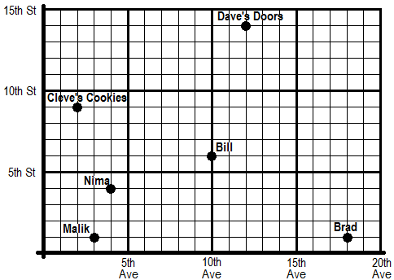

5. | Nima lives at the corner of 4th Ave and 4th St. Bill lives at the corner of 10th Ave and 6th St.  Nima and Bill’s favorite bakery is located halfway between them. Find the location of the bakery.
 | The bakery is located at the corner of ______ Ave. and ______ St.
6. | Cleve’s Cookie Store is at 2nd Ave and 9th St. Dave’s Door Supplier is at 12th Ave and 14th St.  The post office is 1/5 of the way from Cleve’s Cookies to Dave’s Doors. Where is the post office?
 | The post office is located at the corner of ______ Ave. and ______ St.
7. | Malik and Brad live on 1st St—Malik at 3rd Ave, and Brad at 18th Ave. There is a market between them that is twice as far from Malik’s house as it is from Brad’s house. Where is the market?
 | The farmer’s market is located at the corner of ______ Ave. and ______ St.
8. | Draw a segment connecting Cleve’s Cookies (C ) to Brad’s house (B ). Find a point P that partitions directed line segment $\overset{⃑}{\text{CB }}$ in a ratio of 3 : 5.
 | Point P is located at the corner of ______ Ave. and ______ St.

