Accel. PreCalculus Name _______________________________________

Vector & Parametric Eqns Review Date ________________________________________

For # 1-4, use the given information to write each vector in component form.

1.  where  and  2.  where  and 

3. The magnitude of vector v is 35 and the direction angle is .

4. 

For # 5-6, find the magnitude and direction angle of each vector.

5.  6. 

7. Find the component form, magnitude and direction angle for the given vector:

 where  and 

For # 8-10, find the component form of the resultant vector.

8. ; Find:  9. , ; Find: 

10. , ; Find: 

11. Given and , find a unit vector in the direction of  .

For # 12-13, find the dot product of the given vectors.

12. ,  13.  and 

For # 14-15, state whether the two vectors are parallel, orthogonal, or neither.

14. ,  15.  and 

For # 16-17, find the measure of the angle between the two vectors.

16. 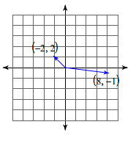 17. 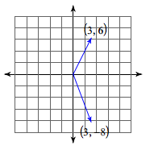

For # 18-20, sketch the curve for each pair of parametric equations.

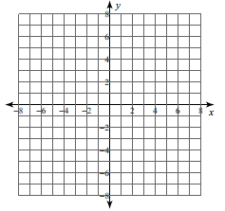18.  ,  19.  ,  , 



20.  , 

For # 21-22, write each pair of parametric equations in rectangular form.

21.  ,  22.  , 

23. A cannon ball is fired across a flat field at an angle of  with an initial speed of 103 ft/s and an initial height of 31ft.

a) Write a set of parametric equations for the motion of the cannon ball.

b) Determine how long the cannon ball was in the air.

c) Determine how far the cannon ball traveled in the air.

d) Determine when the cannon ball reached its maximum height.

e) Determine the maximum height reached by the cannon ball.

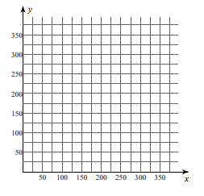 f) Sketch a graph of the parametric equations.