Accel. Geometry Name _____________________________
Other Angle Relationships in Circles Period _____ Date ________________

Theorem: If a tangent and a chord intersect at a point on the circle, then the measure of each angle formed is
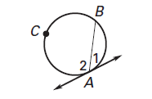
_____________________________________________

_____________________________________________

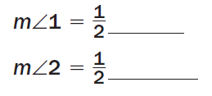

Theorem: If two chords intersect inside a circle, then the measure of each angle is

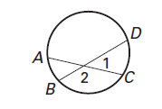
_____________________________________________

_____________________________________________

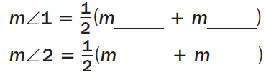

Theorem: If a tangent and a secant, two tangents, or two secants intersect outside a circle, then the measure of the angle formed is

____________________________________________________________________
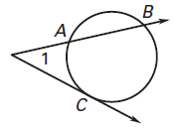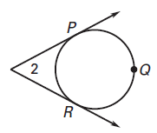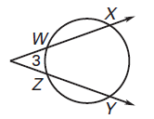

Find the measure of each numbered angle or arc:
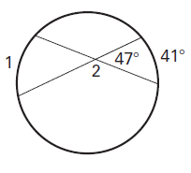
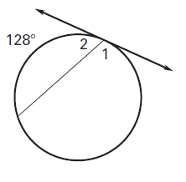
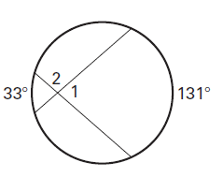
1. 2. 3.

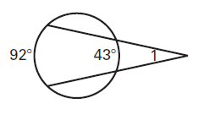
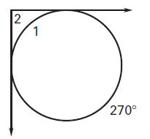
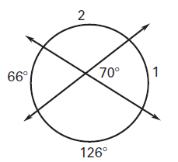
4. 5. 6.

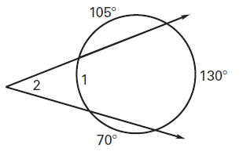
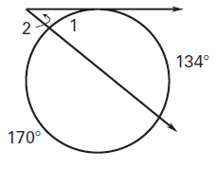
7. 8.

Find the value of x:
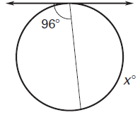
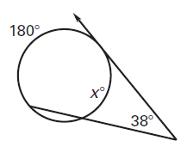
9. 10.

