Name _______________________________________________Date ______ Period ____
Analyzing Darwin’s Finches
Adaptive Radiation
When Charles Darwin stepped ashore on the Galapagos Islands in September 1835, it was the start of five weeks that would change the world of science, although he did not know it at the time. Among other finds, he observed and collected the variety of small birds that inhabited the islands, but he did not realize their significance, and failed to keep good records of his specimens and where they were collected. It was not until he was back in London, puzzling over the birds, that the realization that they were all different, but closely related, species of finch led him toward formulating the principle of natural selection.
In his memoir, The Voyage of the Beagle, Darwin noted, almost as if in awe, "One might really fancy that, from an original paucity of birds in this archipelago, one species had been taken and modified for different ends."
Indeed, the Galapagos have been called a living laboratory where speciation can be seen at work. A few million years ago, one species of finch migrated to the rocky Galapagos from the mainland of Central or South America. From this one migrant species would come many -- at least 13 species of finch evolving from the single ancestor.
This process in which one species gives rise to multiple species that exploit different niches is called adaptive radiation. The ecological niches exert the selection pressures that push the populations in various directions. On various islands, finch species have become adapted for different diets: seeds, insects, flowers, the blood of seabirds, and leaves.
The ancestral finch was a ground-dwelling, seed-eating finch. After the burst of speciation in the Galapagos, a total of 14 species would exist: three species of ground-dwelling seed-eaters; three others living on cactuses and eating seeds; one living in trees and eating seeds; and 7 species of tree-dwelling insect-eaters.
Scientists long after Darwin spent years trying to understand the process that had created so many types of finches that differed mainly in the size and shape of their beaks. Most recently, Peter and Rosemary Grant have spent many years in the Galapagos, seeing changing climatic conditions from year to year dramatically altering the food supply. As a result, certain of the finches have lived or died depending on which species' beak structure was best adapted for the most abundant food -- just as Darwin would have predicted.

Analyzing Darwin’s Finches—Part 1: Analyzing Data

1976 Medium Ground Finch Beak Depth Samples

Data Samples (mm)
6.8
7.2
11.6
10.4
7.5
8.2
9.5
12.0
11.4
11.3
10.2
9.5
9.4
9.1
9.5
9.4
8.9
9.9
9.5
10.3
10.5
8.4
11.6
9.2
7.3

1. Calculate the measures of central tendency for this distribution.

Mean
Median

2. Use the data to report the standard deviation.

Standard Dev.

3. Give the five number summary and information related to outliers.

Minimum
First Quartile
Median
Third Quartile
Maximum
Inter-Quartile Range
1.5 * Inter-Quartile Range
Outlier Upper Limit
Outlier Lower Limit

4. Are there any outliers in your data set? If so, identify them.

5. Draw a box plot of the 1976 Medium Ground Finch Beak Depths.

1978 Medium Ground Finch Beak Depth Samples

Data Samples (mm)
10.1
11.3
10.5
10.4
10.9
12.0
10.6
11.4
11.1
11.0
10.2
10.6
10.0
9.5
9.6
9.7
10.9
10.8
9.4
10.3
8.9
8.4
11.5
10.6
10.6

6. Calculate the measures of central tendency for this distribution.

Mean
Median

7. Use the data to report the standard deviation.

Standard Dev.

8. Give the five number summary and information related to outliers.

Minimum
First Quartile
Median
Third Quartile
Maximum
Inter-Quartile Range
1.5 * Inter-Quartile Range
Outlier Upper Limit
Outlier Lower Limit

9. Are there any outliers in your data set? If so, identify them.

10. Using the same scale as in #5, draw a box plot of the 1978 Medium Ground Finch Beak Depths.
11. Create histograms for the 1976 and 1978 distributions of Medium Ground Finch beak depths on the grids below. Be sure to label each appropriately.

12. Is there any evidence of evolution in the Medium Ground Finch population from 1976 to 1978? Give numerical and/or graphical support for your answer.

13. Read the passage on p. 6. Do your findings align with the findings of Peter and Rosemary Grant? Explain.

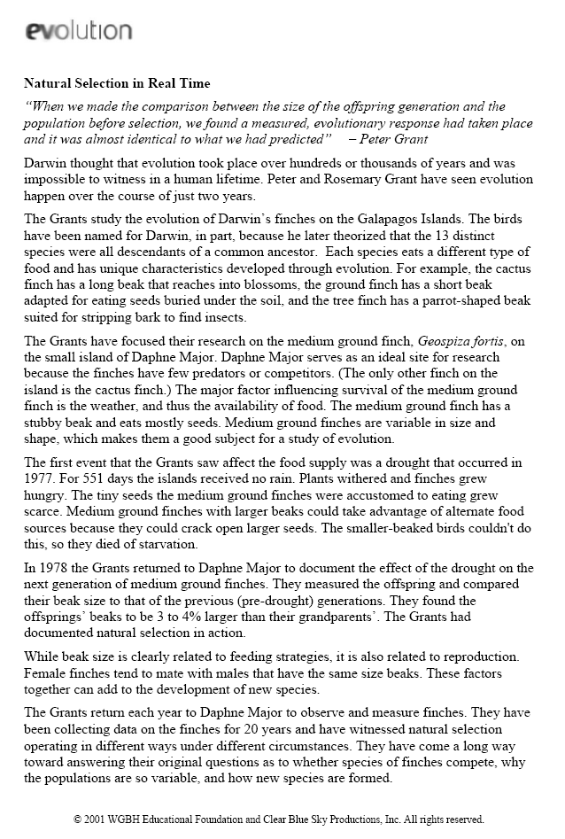
Analyzing Darwin’s Finches—Part 2: Normal Distributions

The incubation time for the Medium Ground Finch is approximately normally distributed, with a mean of 21 days and a standard deviation of one day.

- Draw and label a density curve for this distribution.

- Use the empirical rule to answer the following questions. If 100 eggs are being incubated, how many chicks do we expect will hatch…
- In 19-23 days?

- In 20-22 days?

- In 21 day or fewer?

- In 18-24 days?

The island of Daphne Major has had a steady climate for the past decade. The Medium Ground Finch now has a mean beak depth 10 mm with a standard deviation of 1.5 mm. Assume the distribution is approximately normal.

- What percent of the population has a beak depth…
- Smaller than 7.2 mm?

- Larger than 9mm?

- Between 9 and 11mm?

- In what percentile would a Medium Ground Finch fall if its beak depth is 7.5 mm?

- How many standard deviations above or below the mean is the finch in #4?

- What beak depth would put a Medium Ground Finch in the top quartile?

- What must a finch’s beak depth be to fall in the top 10%?

- Find the IQR of beak depths.

- Suppose the mean beak depth increased to 10.5 mm, and the first quartile was 8.1mm. Find the standard deviation.

Analyzing Darwin’s Finches—Part 3: Interpreting Graphics

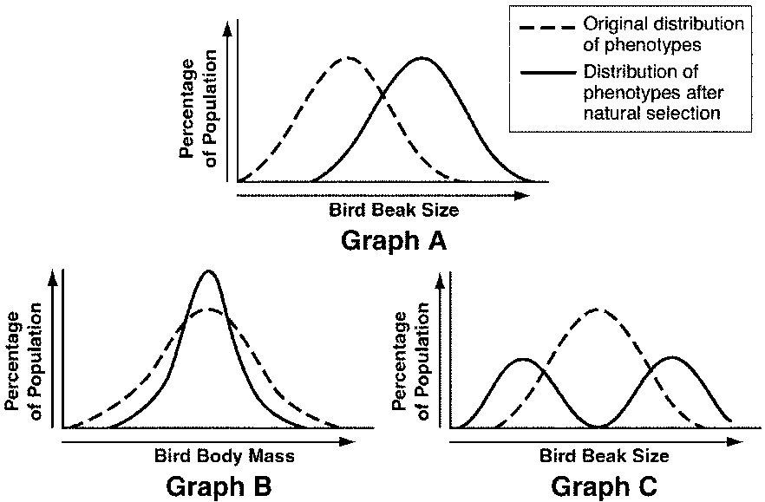

Figure 16–1

1. According to Graph A in Figure 16–1, what has occurred?

2. According to Graph B in Figure 16–1, what has occurred?

3. According to Graph C in Figure 16–1, what has occurred?

4. Which of the three graphs shown in Figure 16–1 might show a population of birds with members that specialize in different types of food? Explain.

5. What factors or conditions might have led to the change shown in Graph A of Figure 16–1.

