Accelerated Geometry Name ____________________
Mutually Exclusive Events Date ____________________

Mutually Exclusive Events:

Probability of events that ARE Mutually Exclusive:

Probability of events that ARE NOT Mutually Exclusive:

In the following examples, which outcomes are mutually exclusive? (Check all that apply)
______ Drawing one card from a standard deck and getting an ace or a 9
______ Drawing one card from a standard deck and getting a king or a club
______ Drawing a candy bar or an apple out of a Halloween grab bag that has 10 caramel candy bars, 15 peanut butter candy bars, and 5 apples
______ Drawing a candy bar or something with caramel out of a Halloween grab bag that has 10 caramel candy bars, 15 peanut butter candy bars, and 5 apples

Practice:
1. Trevor reaches into a can that contains 30 quarters, 25 dimes, 40 nickels, and
15 pennies. What is the probability that the first coin he picks is a quarter or a penny?

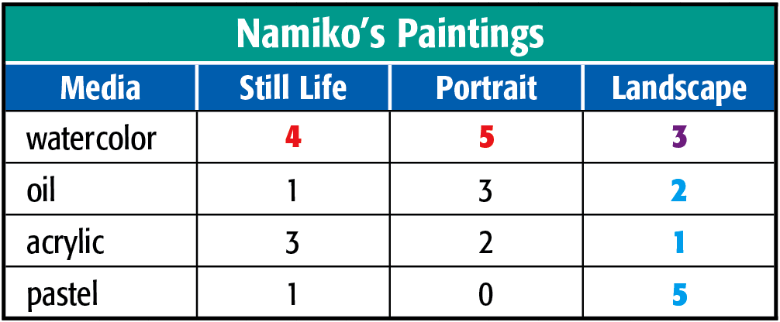
2. Use the table below. What is the probability that Namiko selects a watercolor or a landscape?

3. Use the table. What is the probability that if a high school athlete is selected at random that the student will be a sophomore or a basketball player?
