Accel. PreCalc. Name _______________________

More Polar Graphing Date _______________________

**Lemniscates**

1. Go to Desmos.com. Change your graph setting to polar (look for the wrench symbol in the top right) with radians, type in the following equation:  , and set up a slider for the value of a. This is the general form for a lemniscate equation.
2. What happens when you change the value of a? What part of the graph changes?
3. Let’s look at the specific graph for 
   1. 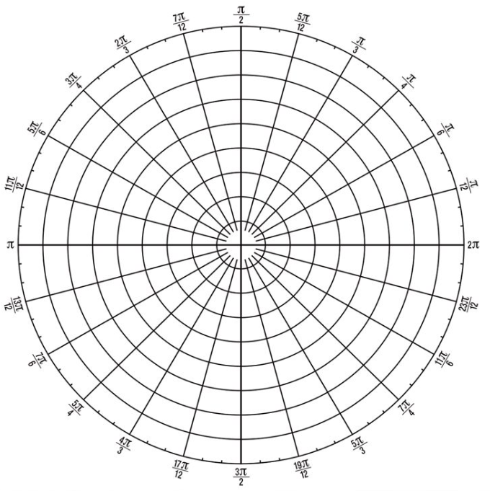Using your calculator, complete the table below and graph the points:

|  |  |
| --- | --- |
|  | r |
| 0 |  |
|  |  |
|  |  |
|  |  |
|  |  |
|  |  |
|  |  |
|  |  |
|  |  |
|  |  |
|  |  |
|  |  |
|  |  |
|  |  |
|  |  |
|  |  |
|  |  |
|  |  |

* 1. What values of r do you get for  ? Why? Show mathematically why this happens.
  2. What are some other values where this happens?

1. Go back to your Desmos graph and change the equation to . How does this compare to the equation with cosine? Does the value of a still control the same part of the graph?
2. Let’s look at the specific graph for 
   1. Using your calculator, complete the table below and graph the points:

|  |  |
| --- | --- |
|  | r |
| 0 |  |
|  |  |
|  |  |
|  |  |
|  |  |
|  |  |
|  |  |
|  |  |
|  |  |
|  |  |
|  |  |
|  |  |
|  |  |
|  |  |
|  |  |
|  |  |
|  |  |
|  |  |

* 1. What values of r do you get for  ? Why? Show mathematically why this happens.
  2. What are some other values where this happens?

**Summary:** General Form(s): ___________________________________________________

* The “a” value controls _____________________________________________________
* The sin/cos controls ______________________________________________________