Rational & Radical Relationships
Finding Inverses of Radical Functions Name:
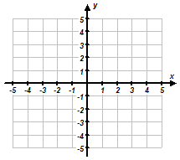
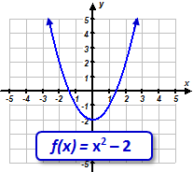
- Consider the function $f\left(x\right)$ shown below. Find the inverse of the function, sketch a graph of the inverse, and determine whether or not the inverse is a function.
Graph of Inverse

•
•

•
•
•
Is the Inverse a Function?
YES NO

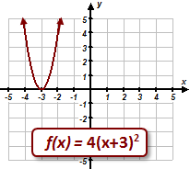
Graph of Inverse
•
•

•

Is the Inverse a Function?
YES NO

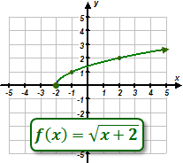
Graph of Inverse

Is the Inverse a Function?
YES NO

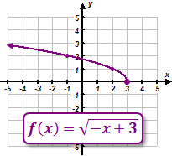
Graph of Inverse

Is the Inverse a Function?
YES NO

- Consider the function $f\left(x\right)$ shown below. Find the inverse of the function, sketch a graph of the inverse, and determine whether or not the inverse is a function.
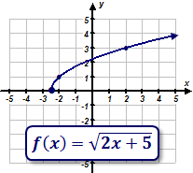
Graph of Inverse

Is the Inverse a Function?
YES NO

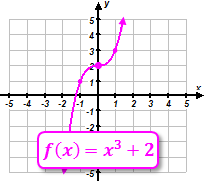
Graph of Inverse

Is the Inverse a Function?
YES NO

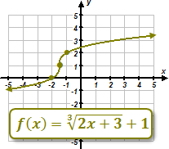
Graph of Inverse

Is the Inverse a Function?
YES NO

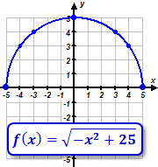
Graph of Inverse

Is the Inverse a Function?
YES NO

