GRAPHING THE SINE FUNCTION

|  |  |
| --- | --- |
| x | *f(x)* = sin x |
| 0 |  |
|  |  |
|  |  |
|  |  |
|  |  |
|  |  |
|  |  |
|  |  |
|  |  |

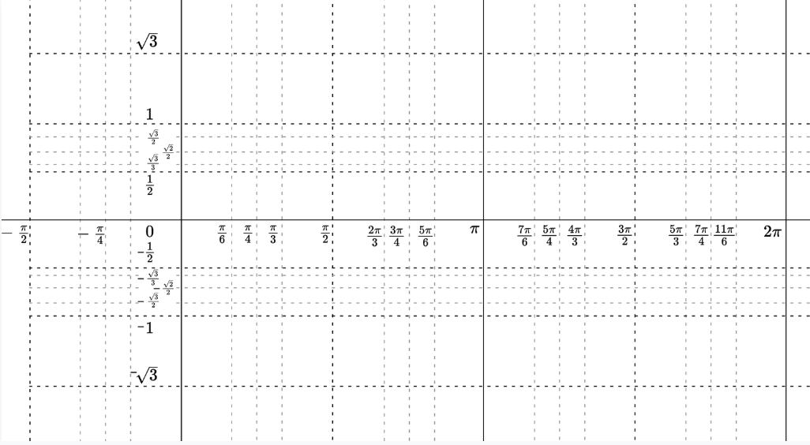

**Sinusoid:**

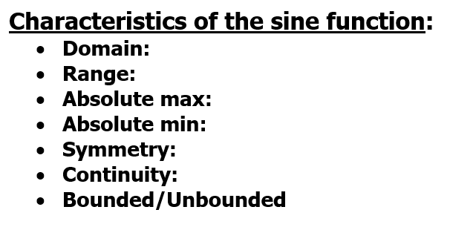

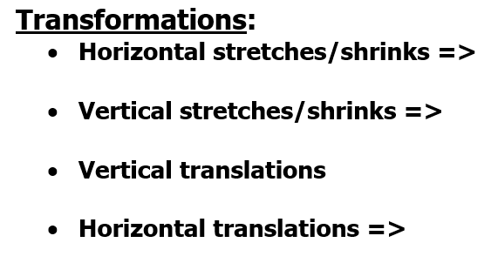

AMPLITUDE

|  |  |  |  |
| --- | --- | --- | --- |
| x | 3 sin x | ½ sin x | -5 sin x |
| 0 |  |  |  |
|  |  |  |  |
|  |  |  |  |
|  |  |  |  |
|  |  |  |  |
|  |  |  |  |
|  |  |  |  |
|  |  |  |  |
|  |  |  |  |
|  |  |  |  |
|  |  |  |  |
|  |  |  |  |
|  |  |  |  |

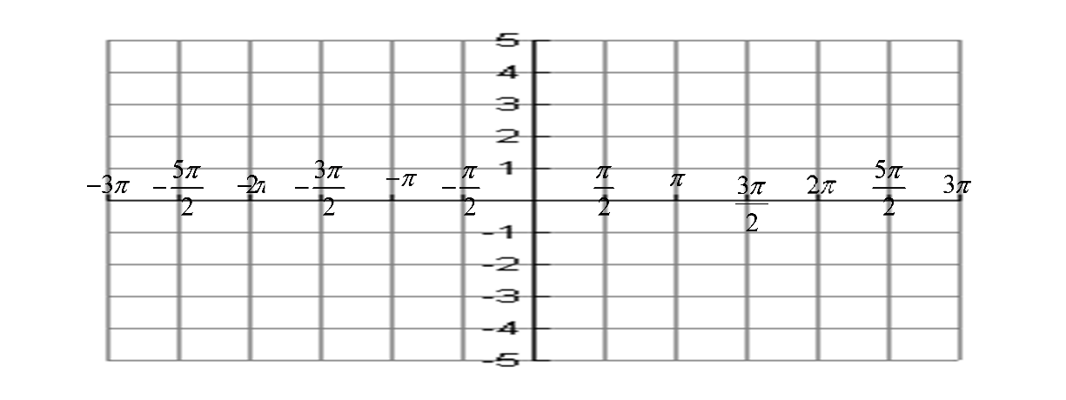

Vertical Shift



*f(x)* = sin x + 2



*f(x)* = sin x - 1



*f(x)* = 3 sin x +1



*f(x)* = -½ sin x - 3

PERIOD

PERIOD

|  |  |
| --- | --- |
| x | y |
| 0 |  |
| $$\frac{π}{2}$$ |  |
| $$π$$ |  |
| $$\frac{3π}{2}$$ |  |
| $$2π$$ |  |



y = sin x

Example 1: y = sin 2x

Example 2: y = $\sin{\frac{1}{2}x}$

Example 3: y = $\sin{\frac{1}{3}x}$



Phase Shifts

Example 1: y = $\sin\left(x-\frac{π}{2}\right)$

Example 2: y = $\sin\left(x+π\right)$

Example 3: y = $-sin\left(x-\frac{π}{4}\right)$

Combining Period Changes

& Phase Shifts

Example 1: y = $\sin\left(2x-\frac{π}{2}\right)$

Example 2: y = $\sin\left(4x-3π\right)$



Putting It All Together

Example 1: y =

Example 2: y =

Example 3: y =

Example 4: y =