Accel. PreCalculus Name ____________________
Graphing Sine Functions Date _____________________
Amplitude Changes and Vertical Shifts

Graph each function. State the amplitude, vertical shift, minimum value, and maximum value.

1. $y=4\sin{θ+2}$ 2. $y=\frac{1}{2}\sin{θ+1}$ 3. $y=-1+\frac{1}{2}\sin{θ}$

4. $y=3\sin{θ+\frac{3}{2}}$ 5. $y=-4\sin{θ-1}$ 6. $y=\frac{1}{2}\sin{θ-4}$

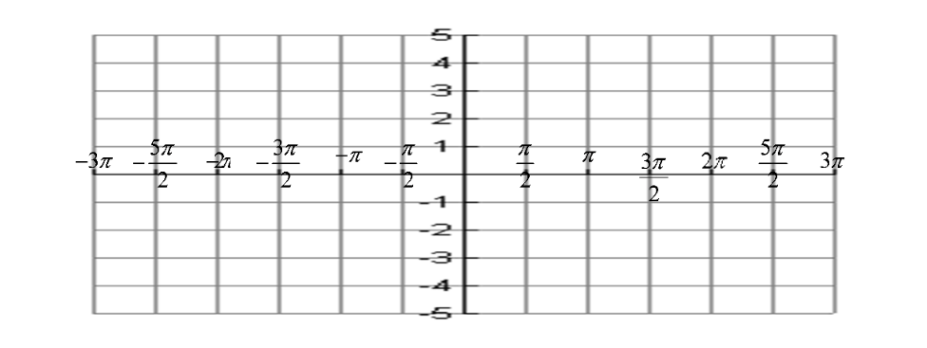
7. $y=-2\sin{θ-2}$ 8. $y=-\frac{1}{2}\sin{θ-3}$ 9. $y=-2+\sin{θ}$

