GRAPHING THE COSINE FUNCTION

|  |  |
| --- | --- |
| x | *f(x)* = cos x |
| 0 |  |
|  |  |
|  |  |
|  |  |
|  |  |
|  |  |
|  |  |
|  |  |
|  |  |

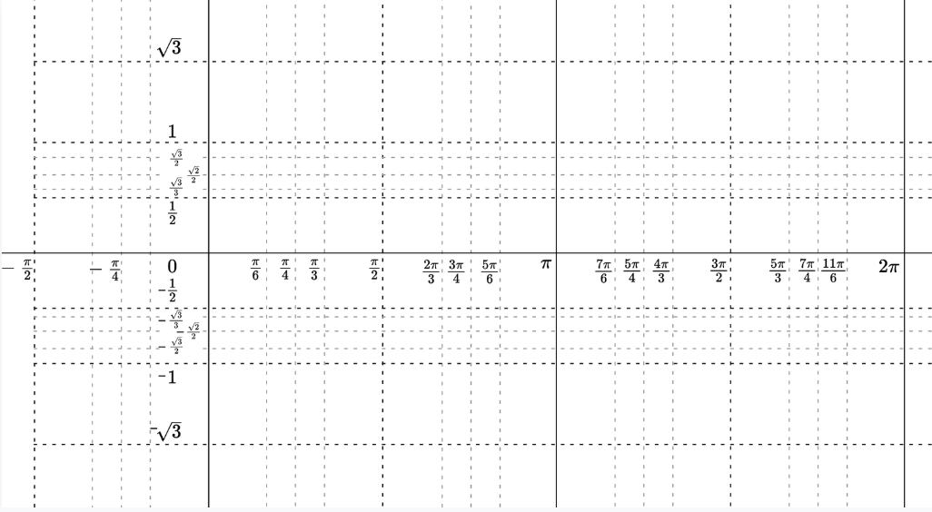

**Characteristics of the cosine function:**

* + - * **Domain:**
      * **Range:**
      * **Absolute max:**
      * **Absolute min:**
      * **Symmetry:**
      * **Continuity:**
      * **Bounded/Unbounded**

AMPLITUDE AND VERTICAL SHIFTS

Graph each of the following functions. State the amplitude and the vertical shift.

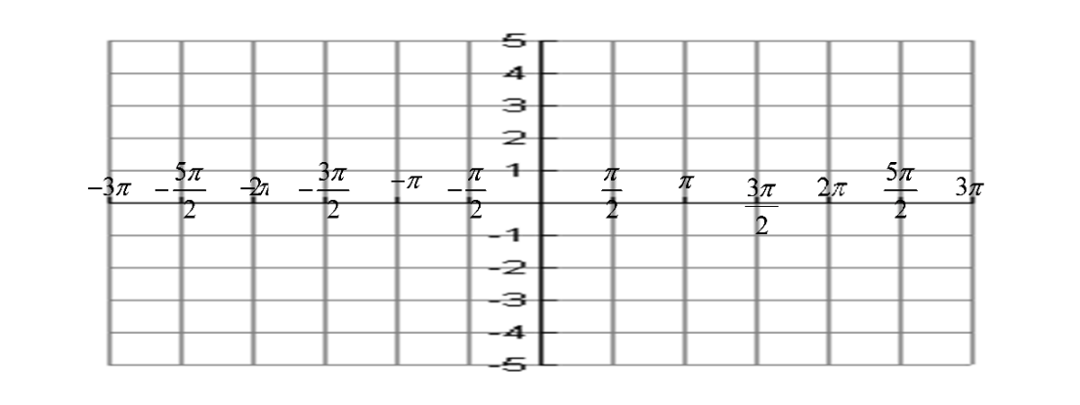1. $y=2\cos{θ-2}$ 2. $y=\frac{1}{2}\cos{θ}$ 3. $y=3\cos{θ+2}$ 4. $y=4\cos{θ-2}$

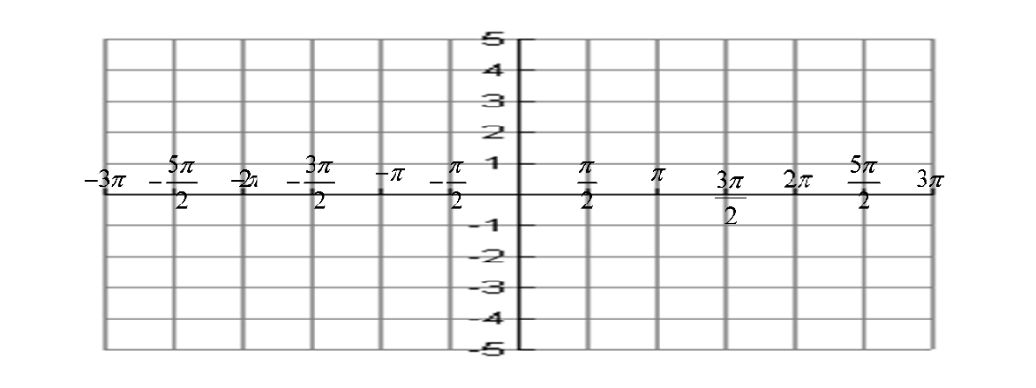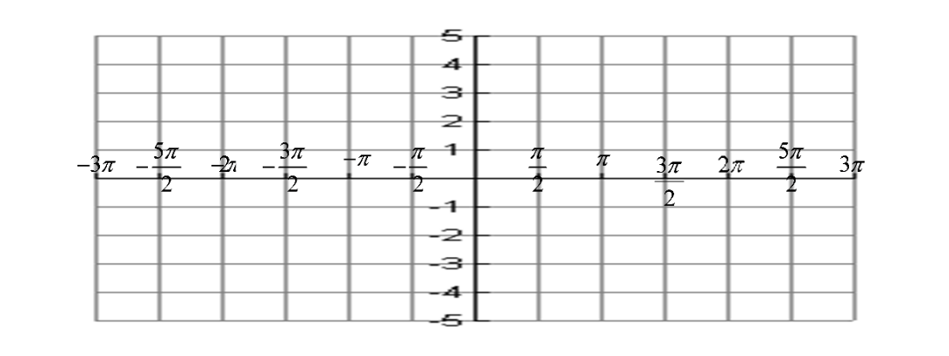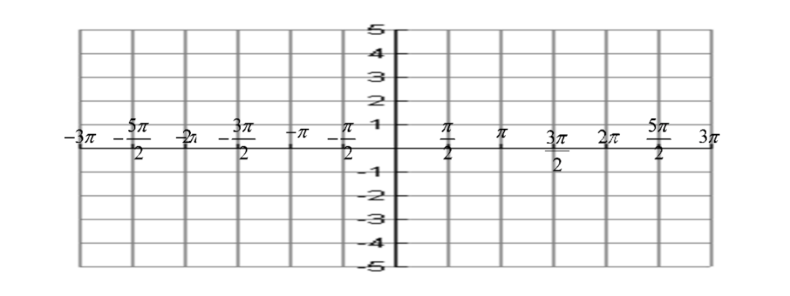

PERIOD AND PHASE SHIFTS

Graph the following functions. State the period, amplitude, phase shift and vertical shift if any.

1. 2. 3.

4. 5. 6.

7. 8.









