GRAPHING COSECANT

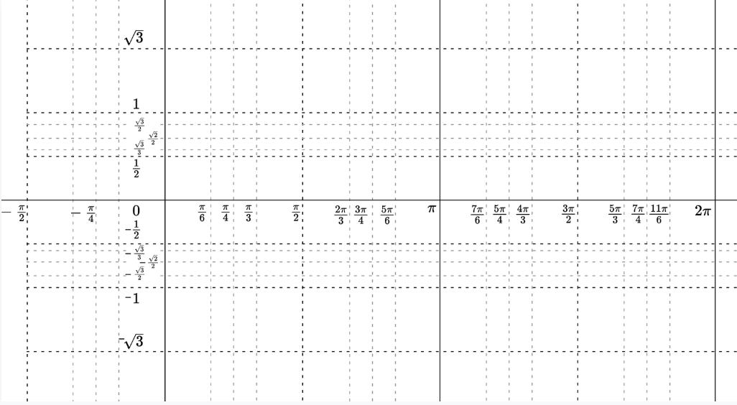

|  |  |
| --- | --- |
| x | *f(x)* = csc x |
| 0 |  |
|  |  |
|  |  |
|  |  |
|  |  |
|  |  |
|  |  |
|  |  |
|  |  |

**Characteristics of the Cosecant function:**

* + - * **Domain:**
      * **Range:**
      * **Absolute max:**
      * **Absolute min:**
      * **Symmetry:**
      * **Continuity:**
      * **Bounded/Unbounded**

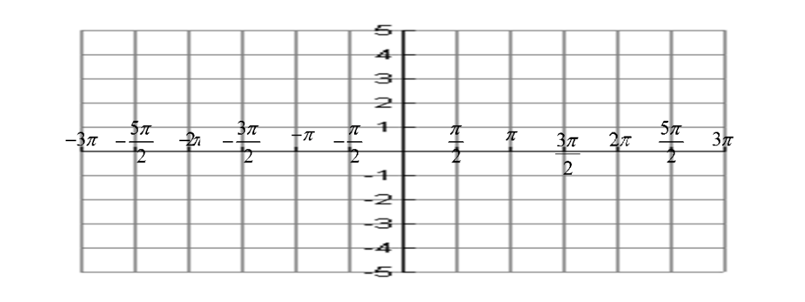Example 1: $y=\csc{2x}$

Example 2: $y=\csc{ 2\left(x-\frac{π}{2}\right)}$

Example 3: $y=-\csc{\frac{1}{2}x}$



Example 4: $y=\csc{2x+3}$

Example 5: $y=\csc\left(\frac{x}{3}-\frac{π}{3}\right)-2$

