Name _____________________________

Period _____ Date ________________

For each graph, determine the following:
The domain and range of the function.
The intervals of x on which f(x) is increasing and decreasing, if any.
The maximum and minimum values (absolute and/or local), if any.
The x- and y-intercepts, if any.
The function’s end behavior.

Example
 | 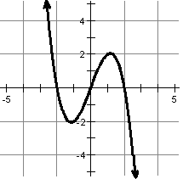 | Domain?  Range?  Interval(s) of increase?  Interval(s) of decrease?  Maximum(s)?  Minimum(s)?  x-intercept(s)?  y-intercept(s)?  End behavior: | _____________________  _____________________  _____________________  _____________________  _____________________  _____________________  _____________________  _____________________  f(x) → _______ as x → -∞  f(x) → _______ as x → +∞
1. | 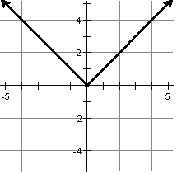 | Domain?  Range?  Interval(s) of increase?  Interval(s) of decrease?  Maximum(s)?  Minimum(s)?  x-intercept(s)?  y-intercept(s)?  End behavior: | _____________________  _____________________  _____________________  _____________________  _____________________  _____________________  _____________________  _____________________  f(x) → _______ as x → -∞  f(x) → _______ as x → +∞
2. | 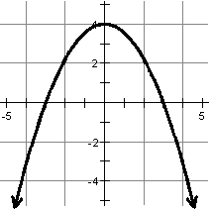 | Domain?  Range?  Interval(s) of increase?  Interval(s) of decrease?  Maximum(s)?  Minimum(s)?  x-intercept(s)?  y-intercept(s)?  End behavior: | _____________________  _____________________  _____________________  _____________________  _____________________  _____________________  _____________________  _____________________  f(x) → _______ as x → -∞  f(x) → _______ as x → +∞
3. | 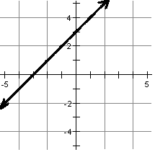 | Domain?  Range?  Interval(s) of increase?  Interval(s) of decrease?  Maximum(s)?  Minimum(s)?  x-intercept(s)?  y-intercept(s)?  End behavior: | _____________________  _____________________  _____________________  _____________________  _____________________  _____________________  _____________________  _____________________  f(x) → _______ as x → -∞  f(x) → _______ as x → +∞
4. | 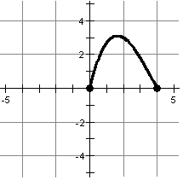 | Domain?  Range?  Interval(s) of increase?  Interval(s) of decrease?  Maximum(s)?  Minimum(s)?  x-intercept(s)?  y-intercept(s)?  End behavior: | _____________________  _____________________  _____________________  _____________________  _____________________  _____________________  _____________________  _____________________  f(x) → _______ as x → -∞  f(x) → _______ as x → +∞
5. | 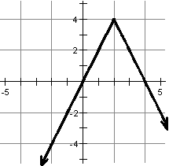 | Domain?  Range?  Interval(s) of increase?  Interval(s) of decrease?  Maximum(s)?  Minimum(s)?  x-intercept(s)?  y-intercept(s)?  End behavior: | _____________________  _____________________  _____________________  _____________________  _____________________  _____________________  _____________________  _____________________  f(x) → _______ as x → -∞  f(x) → _______ as x → +∞
6. | 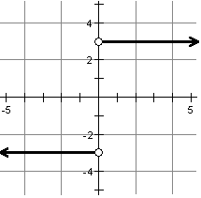 | Domain?  Range?  Interval(s) of increase?  Interval(s) of decrease?  Maximum(s)?  Minimum(s)?  x-intercept(s)?  y-intercept(s)?  End behavior: | _____________________  _____________________  _____________________  _____________________  _____________________  _____________________  _____________________  _____________________  f(x) → _______ as x → -∞  f(x) → _______ as x → +∞

