Name: ______________________________________________ Pd: _____ Date: ___________________

**Accelerated Geometry B / Algebra II**

**Coordinate Geometry (GSE Unit 2)**

**Part 1: Multiple Choice Questions**

**Solve each problem and show your work on the space provided. Write the correct answer in the box.**

1. What is the distance between the points (3.5, -2.6) and (-4.2, 7.5), approximately?

|  |
| --- |
|  |

1. 13.6 (B) 13.7 (C) 12.7 (D) 12.6
2. What is the slope of the line joining the points (-8, 4) and (6, -2)?

|  |
| --- |
|  |

(A)  (B)  (C)  (D) 

1. What is the midpoint of the line segment joining the points (-3, 5) and (-8, 2)?

(A)  (B)  (C)  (D) 

|  |
| --- |
|  |

4. If M (3, 4) is the midpoint of the line segment joining the points (2, -3) and (4, x), what is the value of x?

|  |
| --- |
|  |

(A) 11 (B) -11 (C) 6 (D) -6

|  |
| --- |
|  |

5. If the perimeter of the rectangle given in the figure is 24 then what is the value of x?

|  |
| --- |
|  |

(A) 25 (B) 13 (C)  (D)  2x-5

4-x

**Part 2: Free Response Questions**

**Solve each problem and show your work on the space provided. Circle your final answer.**

6. Find the (a) perimeter and (b) area of the figure formed by the following sets of points:

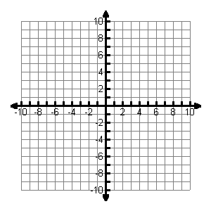 E (2, 9), F (10, 2), G (2, 2)

1. Perimeter:

|  |
| --- |
|  |

(Perimeter)

1. Area:

|  |
| --- |
|  |

(Area)

 7. Find the (a) perimeter and (b) area of the figure formed by the following sets of points:

T (-5, 0), U (7, 3), V (9, -6), W (-4, -9)

1. Perimeter:

|  |
| --- |
|  |

(Perimeter)

1. Area:

|  |
| --- |
|  |

(Area)

8. What is the type of quadrilateral formed by the following points: P (2, 1), Q (6, -2), R (10, 1), and S (6, 4)

Show all your work with entire proof.

|  |
| --- |
|  |

(Quadrilateral)