|  |  |
| --- | --- |
| CIRCLES | |
| **Geometric Definition:**   * as a conic section: | **Equation:**   * without shifts:   the _____________________ is at (0,0). |
| * in the coordinate plane:   the set of all points that… | * with shifts: |
| **Characteristics:**   |  | | --- | | * center: | | * radius: | | * diameter: | | **Graph:**   |  | | --- | |  | |

**Example 1:** Identify the center and the radius of each circle then draw the graph.

a.  b. 

C: R: C: R:

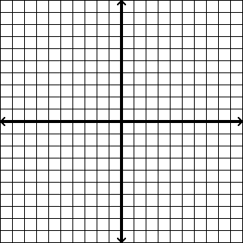

c.  d. 

C: R: C: R:



**Example 2:** Write the standard equation for each circle graphed below.

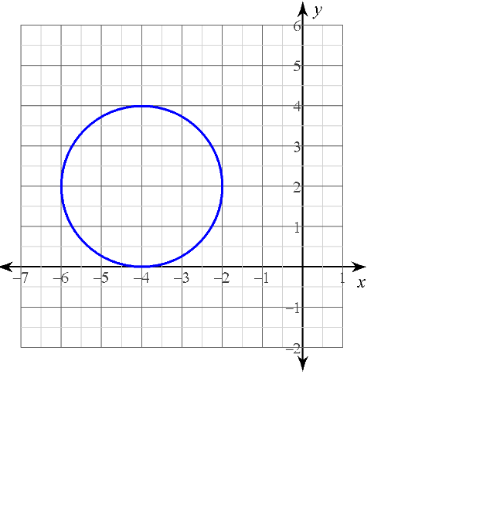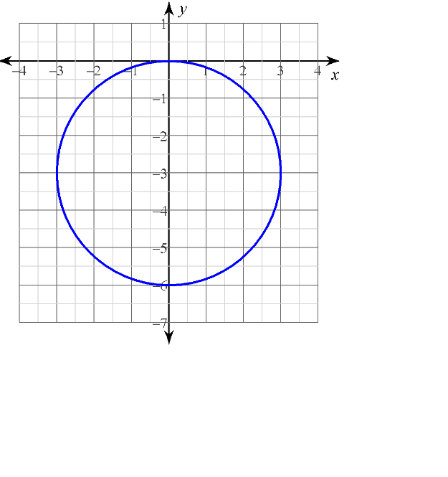

a. b.

**Example 3:** Write the standard equation of a circle with the given radius and center.

a. r = 6; C (0, 0) b. r = 24; C (-3, -3)

**Example 4:** Write the equation of the circle in standard form, given that its center is at (4, -2) and it passes through (2, 5).

**Example 5:**

|  |  |
| --- | --- |
| Write an equation of the circle that has a diameter with endpoints at (-12, 11) and (-2, -13).  center: ___________ radius: _________  (leave radius in exact form) | Is the point (7, 4) on the circle?  Justify with calculations.  Is the point (1, -9) on the circle?  Justify with calculations. |
| **Is the point (1, -9) inside, outside, or on the circle described above?** | |
| **Option 1:** Using the circle’s equation | **Option 2:** Finding distance |
| The point (1, -9) is ____________ the circle. | The point (1, -9) is ____________ the circle. |

Accelerated Geometry Name ____________________________

Equations of Circles Practice Date _____________________________

**Use simplest radical form where appropriate (no decimals!)**

**1.** Find the center and radius of each circle, then graph the circle.

|  |  |  |  |  |
| --- | --- | --- | --- | --- |
|  | **a.** | (*x* – 3) 2 + (*y* + 1) 2 = 4  center: radius:  **GraphPaper-6,6,6,6a** | **b.** | (*x* + 1) 2 + *y* 2 = 18  center: radius:  **GraphPaper-6,6,6,6a** |
|  | **c.** | (*x* – 3) 2 + (*y* + 3) 2 = 9  center: radius:  **GraphPaper-6,6,6,6a** | **d.** | (*x* + 2) 2 + (*y* + 3) 2 = 49  center: radius:  **GraphPaper-6,6,6,6a** |

**2.** Write the standard form equation of the circle shown or described.

|  |  |  |  |  |
| --- | --- | --- | --- | --- |
|  | **a.** |  | **b.** |  |
|  | **c.** | center: (0, -7) radius: | **d.** | center: (0, 0) radius: 2.5 |
|  | **e.** | center: (-3, -3) radius: 6 | **f.** |  |
|  | **g.** | A circle that is tangent to the *x*‑axis that has its center at (-2, 3). | **h.** | A circle’s center is at (4, 2), and the point (1, 6) is on the circle. |
|  | **i.** | A circle has a diameter with endpoints (4, 3) and (10, -7) | **j.** | A circle that is tangent to the y-axis that has its center at (5, 1) |

|  |  |  |
| --- | --- | --- |
| **3.** | **Consider the circle described by this equation: (*x* – 5)2 + (*y* + 1)2 = 52** | |
|  | **a.** | Does the point (-1, 3) lie inside, outside, or on the circle? Justify your answer with calculations. |
|  |  |  |
|  | **b.** | Does the point (-2, 1) lie inside, outside, or on the circle? Justify your answer with calculations. |
|  |  |  |

Investigation: Finding the Equation of a Line Tangent to a Circle

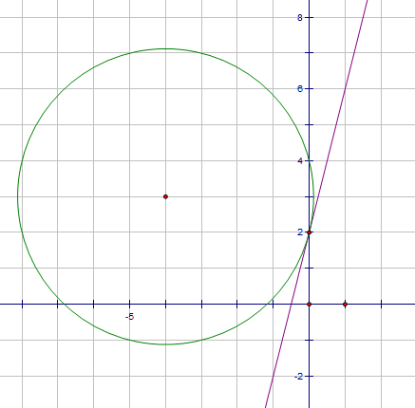

1. Using the picture at the right, complete the following:
   1. Draw a segment from the center of the circle to the point of tangency.
   2. What is the slope of the radius you just drew?
   3. What is the slope of the linear function that is tangent to the circle?
   4. How are the two slopes related?
   5. What does that tell you about the linear function and the radius of the circle?
2. Let’s do another one:
   1. 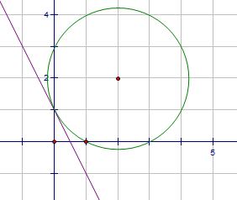Draw a segment from the center of the circle to the point of tangency.
   2. What is the slope of the radius you just drew?
   3. What is the slope of the linear function that is tangent to the circle?
   4. How are the two slopes related?
   5. What does that tell you about the linear function and the radius of the circle?
3. What if you don’t have a picture to look at? Try to find the equation of the line that is tangent to the following circle at the given point: (x + 2)2+(y – 1)2=12 point: (3, -3)
   1. Think about what you did first when you had the pictures to look at. What slope did you find first? Use the above information to find that slope.
   2. How is that slope related to the slope of the tangent line?
   3. So what is the slope of the tangent line?
   4. So now you know the **slope** of the tangent line and a **point** that the line passes through. Use those two pieces of information to write the equation of the tangent line.

Practice with the following problems: Write the equation of the line TANGENT to the circle at the given point.

1. (x + 2)2+(y – 1)2=12 point: (3, -3)

2. (x)2+(y)2=25 point: (3, 4)

Accelerated Geometry Name ______________________

Writing Eqns. Tangent to a Circle Date _______________________

**Write the equation of the line TANGENT to the given circle at the given point.**

1. , (1,4) 2. , (-2,4)

3. , (1,3) 4. , (-8,1)

5. , (-2,6) 6. , (-10,-12)

7. Consider the circle .

1. Write the equation of the line tangent to the circle through the point (2,3).
2. Write the equation of the line tangent to the circle through the point (-2,3).
3. How are the two tangent lines related (slope and y-intercept)?

8.Graph the circle . Then, graph the line tangent to the circle through the point (-4,3). What is the equation of this line?



Write the equation of the circle in standard form given the center and a point P on the circle.

9. C = (3, -7) P = (4, 0)

10. C = (0, 3) P = (2, 5)

Accelerated Geometry Name _____________________

Writing Circles in Standard Form Date ______________________

**Completing the Square:** Completing the square is a method used to solve quadratic equations. It involves rewriting a quadratic so that we get a ___________________

_________________________________. We can also use it to rewrite equations of circles in standard form.

Step 1:

Step 2:

Step 3:

Step 4:

**Examples:** Write the equation of the circle in standard form. Then find the center and the radius.

a. ** b**. 

c. 

**Applying Circle Equations:**

**Example 1:** You put a rotating sprinkler in the center of your front yard to water your grass. When the sprinkler makes a full circle, its diameter is 30 feet.

1. Write an inequality to describe the region getting wet by the sprinkler.
2. If you are standing 4 feet above the sprinkler and 13 feet left of the circle, are you going to get wet?

**Example 2:** Mercedes Benz Stadium has a radius of 250 yards.

1. Write an inequality to describe the region inside the Georgia Dome.
2. If you are standing 275 yards south & 30 yards west of the center of the dome, are you inside or outside the Mercedes Benz Stadium?

Accelerated Geometry Name _______________________

Rewriting Circle Equations Practice Date _______________________

1. Convert each equation to standard form, then find the center and radius of each circle.

|  |  |  |  |  |
| --- | --- | --- | --- | --- |
|  | **a.** | *x* 2 + 8*x* + *y*2 + 6*y* = 20  standard form:  center: radius: | **b.** | *x* 2 + *y* 2 + 4*y* – 3 = 0  standard form:  center: radius: |
|  | **c.** | *x* 2 + 2*x* + *y* 2 + 6*y* – 30 = 5  standard form:  center: radius: | **d.** | *x* 2 + 2*x* + *y* 2 + 4*y* - 4 = 0  standard form:  center: radius: |

**2.** A flower shop advertises free delivery up to a 20 mile radius from the store.

1. Write an inequality for the region covered by free delivery.
2. If John lives 10 miles east and 12 miles south of the store, does he qualify for free delivery?
3. If Amy lives 15 miles west and 14 miles north of the store, does she qualify for free delivery?