Accelerated Geometry Name ____________________________
Cross Sections Date _____________________________

Illustrate the way in which each figure would have to be sliced to obtain the given cross section.
Cube: How would you slice each cube to get cross sections shaped like a square, triangle, rectangle and trapezoid?  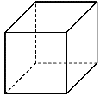 | Square Pyramid: How would you slice each pyramid to get cross sections shaped like a triangle, square, and trapezoid?  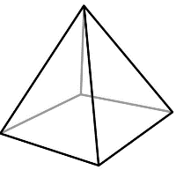
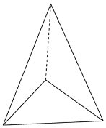  Triangular Pyramid: How would you slice each pyramid to get cross sections shaped like two different types of triangles? | Sphere: How would you slice each sphere to get cross sections shaped like a circle or a great circle?  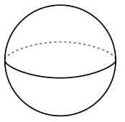
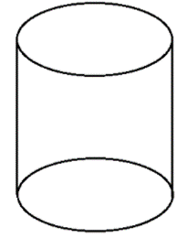  Cylinder: How would you slice each cylinder to get cross sections shaped like a circle or a rectangle? | Cone: How would you slice each cone to get cross sections shaped like a circle or a triangle?  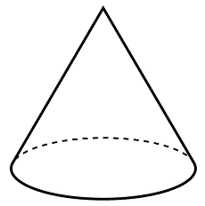

Sketch and state the figure that is the cross section described for the given figure and stated plane.
1. Passing through the center | 2. Parallel to the base | 3. Parallel to the base
4. Parallel to the base  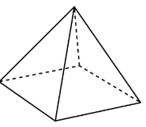 | 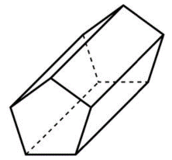  5. Parallel to the base (the pentagon is the base) | 6. Passing through the top with a horizontal plane
7. Perpendicular to the base passing through the vertex | 8. Perpendicular to the base | 9. Perpendicular to the base passing through the vertex
10. Parallel to the base  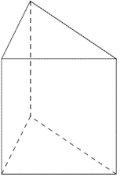 | 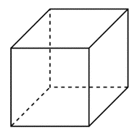  11. Parallel to the base | 12. Perpendicular to the base (the pentagon is the base)
13. Parallel to the base  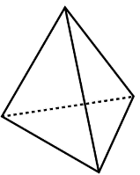 | 14. Perpendicular to the base | 15. At an angle with the base and passes through both the front and back sides of the figure

