Accelerated Geometry Name _______________________
Cross Section & Rotation Practice Date________________________

1. Which of the following could represent the different cross sections of a cylinder? | 5. Which of the following shows a cross section that is parallel to the base of a pentagonal prism?
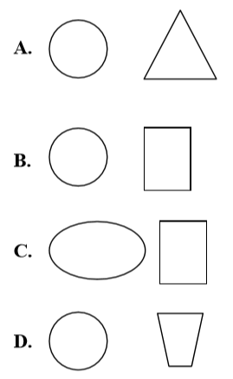 | 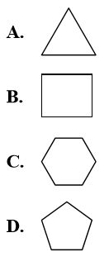
2. Which of the following shapes show the cross section of a triangular prism that is perpendicular to the base? | 6. Which of the following are possible cross sections of a cube?
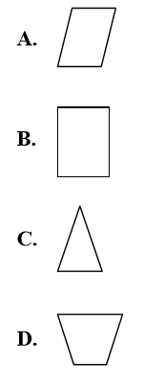 | 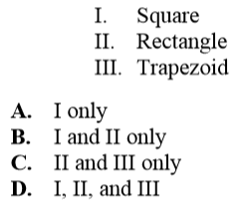
3. Which of the following figures does not have a triangular cross section? | 7. Which of the following is a cross section that is parallel to the base of a cone?
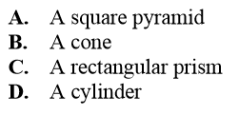 | 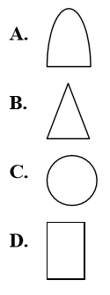
4. A plane intersects a square pyramid at an angle oblique to its base. What describes the shape of the cross section that is produced? | 8. All of the following correctly identify a correct cross section for a square pyramid except which one?
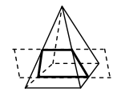  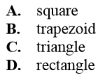 | 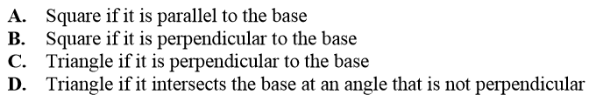

9. Sketch a cross section that is parallel to the base of a cylinder and one that is perpendicular to the base of a cylinder.

10. Sketch a cross section for each of the following figures.

a. Sphere

b. Hexagonal pyramid, parallel to the base

c. Triangular prism, perpendicular to the base

11. Imagine rotating the rectangle shown about the y-axis

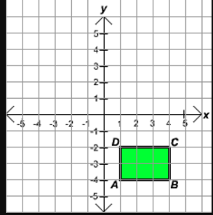

a. Identify what type of figure the rotation makes.

b. Find the volume of the resulting space figure.

