Accelerated Geometry Name _______________________
Cavalieri’s Principle Date _______________________

https://www.youtube.com/watch?v=6Ohmnnbihkg

Cavalieri’s Principle: If two solids have the same _____________ and the same ________________________________ at every level, then they have the same ______________.

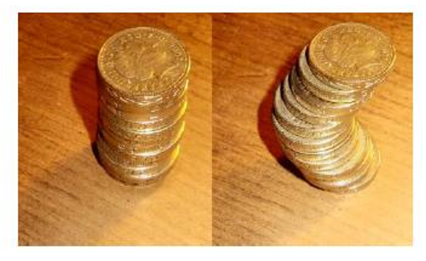

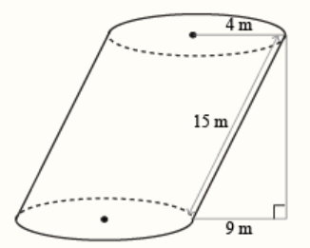
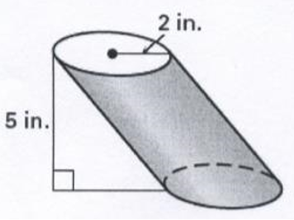
Example 1: Example 2:

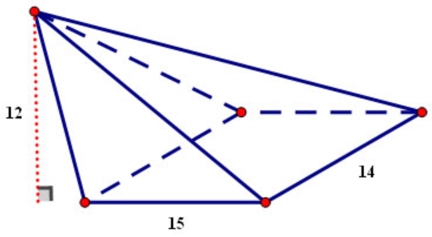
Example 3:

