Accel. Precalc. Name _______________________
Biorhythms Date _______________ Per _____

Biorhythm theory states that a person’s biological functioning is controlled by three phenomena that vary sinusoidally with time. “Bio” means life and “rhythm” pertains to flow with regular movement. Biorhythm charts illustrate the principle that we are influenced by physical, emotional, and intellectual cycles. In other words, depending on your birthday, there are certain days that you will have a physiological high. Many people report that they can improve the quality of their lives by monitoring the highs and lows of these cycles and acting accordingly. For example, you might try to schedule important exams during your intellectual highs, avoid talking to your significant other during your emotional lows, or arrange the lineup of your baseball team around the physical highs of your teammates.

The three graphs are given by $y=a\sin\left(bx\right)$ where x = 0 corresponds to a person’s day of birth and A = 1 is used to denote 100% potential. Biorhythm cycles have varying periods. We’ve already established that the function $y=a\sin\left(bx\right)$ has a period of $\frac{360°}{b}$. We will use this fact to help us graph biorhythm cycles.

- The physical cycle has a period of 23 days. Use this to find the value of b and then write the equation for a physical biorhythm. ____________________________________ Enter this into line 1 of Desmos.
- The emotional cycle has a period of 28 days. Use this to find the value of b and then write the equation for an emotional biorhythm. ____________________________________ Enter this into line 2 of Desmos.
- The intellectual cycle has a period of 33 days. Use this to find the value of b and then write the equation for an intellectual biorhythm. ____________________________________ Enter this into line 3 of Desmos.
On Feb. 2, 2014, the Seattle Seahawks won the Super Bowl and Malcolm Smith was named MVP of the game. Malcolm was born July 5, 1989. By graphing his three biorhythms for the month of February, we can predict if February 2nd was his day to achieve this feat.
First, we need to find the appropriate part of the x-axis to view. We need to establish a min. and max. x-value.
- The minimum x-value is equal to the number of days that Malcolm has lived from his birth to the first day of February, 2014. To do this, we need to take into account leap years (1956, ’60, ’64,…,’92). The following formula will help us find our min. x-value: X-min = 24(365) + 6 + 210
What do each of these numbers represent?
24 = ________________ 365 = _________________ 6 = ________________ 210 = ______________

What is our minimum x-value? ____________

- You can obtain the max. x-value by adding the number of days of the month you’re looking at to the min. x-value. What is our max. x-value? ____________________ Use the min and max x-values to adjust your viewing window in Desmos.

Using three different colors, sketch and label Malcolm’s three biorhythm cycles below.
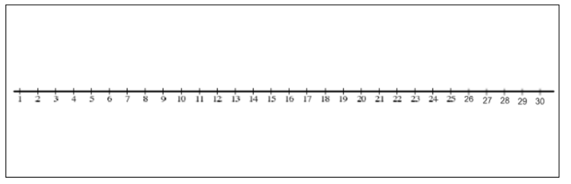

- What day(s) of the month was Malcolm at his emotional high? _______________________________

- What day(s) of the month was Malcolm at his intellectual high? ______________________________

- What day(s) of the month was Malcolm at his physical high? _______________________________

- What was Malcolm’s physical level on Feb. 2nd (as a %)? __________________________________

Now, graph your biorhythms for the upcoming month. The functions will not change, only the range. Use the formulas on the previous page to help you.
Your birthday (Month/Day/Year): ______________________
X-min. = (_________)(365) + __________ + _____________ = _______________
X-max. = ______________

- What is your best physical day of the month? ________________ Emotional? ________________

- When should I schedule a test for you to do your best? Why?

- What, during the next month, will be your best overall day during the month? Explain.

- When, during the next month, will your overall performance be the lowest? __________________

- According to the same theory, the most dangerous time, your “critical day” for a particular function (illness, bad decisions, clumsiness) is when it crosses the time axis. During the next month, when is your critical day for each function?
  - Physical? ________________
  - Emotional? _______________
  - Intellectual? _________________

- Pick a date this month that is important to you. ________________

- Which biorhythm do you want to be high on this date? ______________ Is it? ___________

