Accel. Geometry Name _______________________
Area and Perimeter Practice Date _______________________

Find the area of the shaded regions.
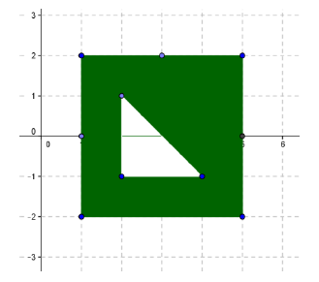
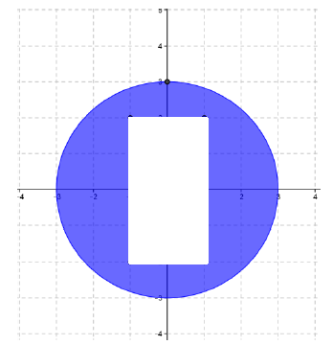
- 2.

3. Given the figure below, calculate the perimeter and the area.
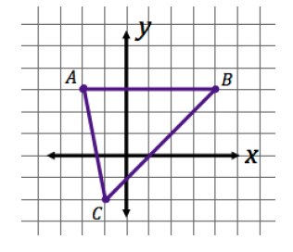

4. Find the area of the triangle with the following vertices: A(0, 0), B(3, 2), C(-2, 6)

Calculate the area and perimeter of the following two figures.
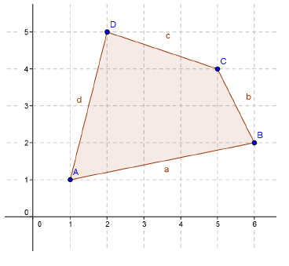
5.

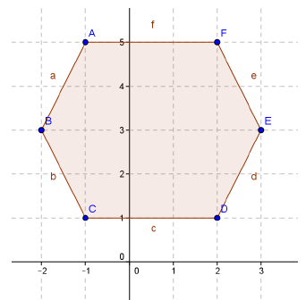
6.

