Accelerated Geometry Name _______________________
Area and Perimeter in the Coord. Plane Date _______________________

1. Find the perimeter of $∆ PQR$ with vertices located at P(-4, -2), Q(-1, -6), R(6, -3)
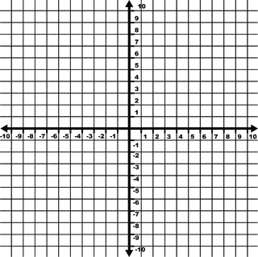

2. Find the perimeter of $∆ ABC$ with vertices located at A(-2, -2), B(2, -2), C(0, 5)

3. Find the area of $∆ UGA$ with vertices located at U(-3, 3), G(1, 7), A(5, 3)

4. Find the area of $∆ MNO$ with vertices located at M(1,4), N(-1, 1), O(-4, 3)

5. Find the perimeter and area of $∆ XYZ$ with vertices located at X(1, 1), Y(-3, 3), Z(6, 2)

Find the area of the given figures.
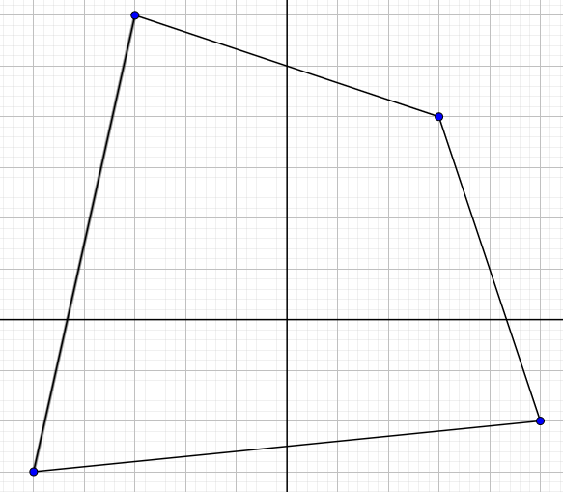
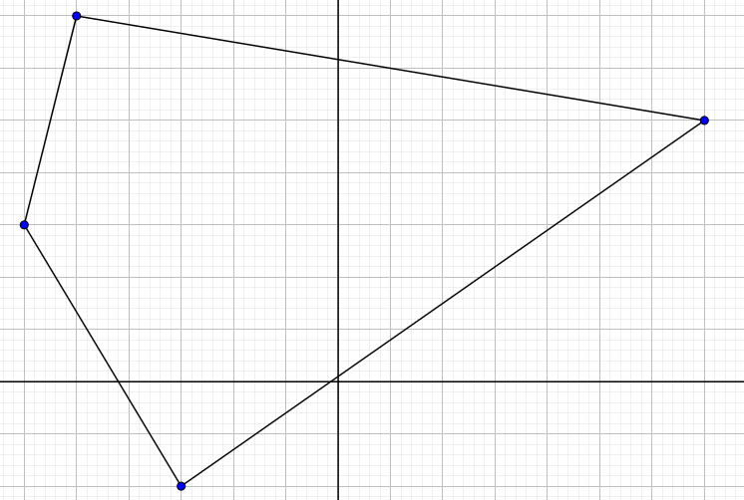
6. 7.

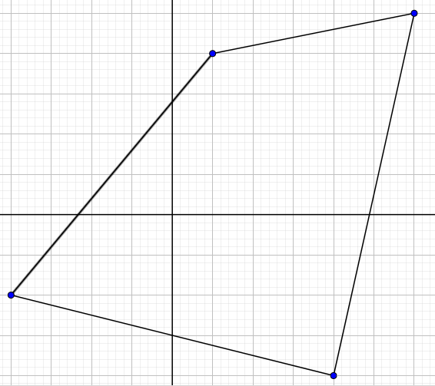
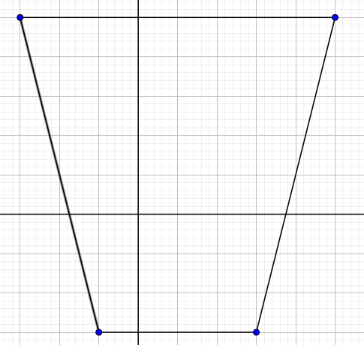
8. 9.

