Name ______________________

Date _______________________

Sector Practice Problems

Find the area of the shaded sectors.

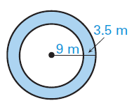1. 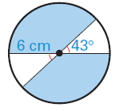 2. 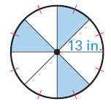 3.

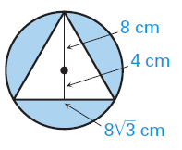4. 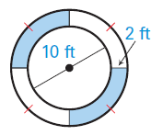 5. 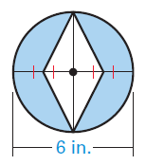 6.

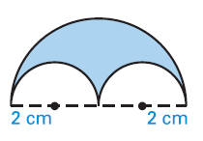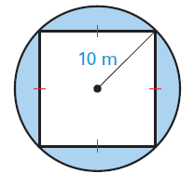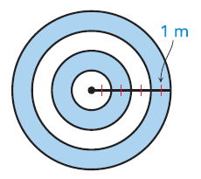7. 8. 9.

10. 