Accel. Geometry Name ___________________________

Arc Length and Sector Area Date ___________________________

|  |  |
| --- | --- |
|  | Circumference of a circle:    Arc Length:  Area:  Sector of a Circle: |

|  |  |
| --- | --- |
| radius = 20 | Divide this circle into 4 congruent sectors. Shade 1 of them.  Fraction that is shaded =  Central angle =  Area of the whole circle =  Area of the sector =  Circumference of the whole circle =  Arc length = |
| radius = 20 | Divide this circle into 8 congruent sectors. Shade 5 of them.  Fraction that is shaded =  Central angle =  Area of the whole circle =  Area of the sector =  Circumference of the whole circle =  Arc length = |
|  |  |
| radius = *r* | Area of a sector:  Arc length: |

Find the area and circumference of the circle.

|  |  |
| --- | --- |
| 1. |  |
| 2. |  |
| 3. |  |

Find the arc length and the area of the sector.

|  |  |
| --- | --- |
| 4. |  |
| 5. |  |
| 6. |  |

7. Find the length of arc AB 8. Find the length of arc AB

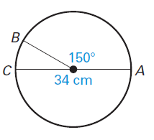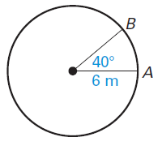

9. Find the circumference of circle Q. 10. Find the radius of circle N

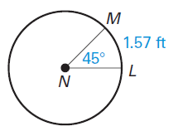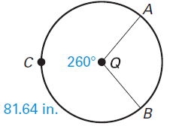

Find the areas of the shaded sectors.

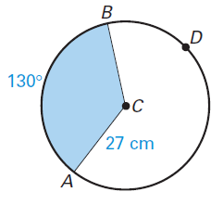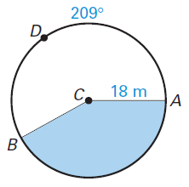

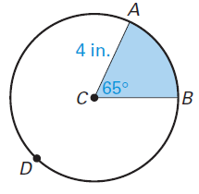11. 12. 13.

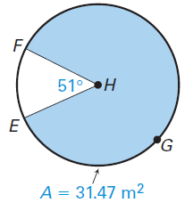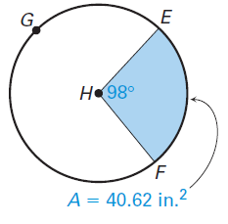14. Find the radius of circle H. 15. Find the diameter