AP Statistics—Confidence Intervals for Proportions and Means Name__________________________Pd__
FRAPPY 2013 #1
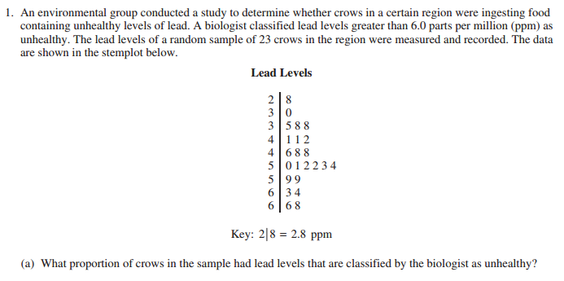

2011B #5
