STATION #1
Percent | Year's Earnings
20% | $50,000 Loss
30% | $0
40% | $50,000 Profit
10% | $150,000 Profit

1. You plan to open a new McDougal’s Fried Chicken and found these stats for similar restaurants. Calculate and interpret the mean.

2. A six-sided die is biased. The numbers one to five are equally likely to land face up, but six is twice as likely to land face up as each of the other numbers. If X represents the number showing face up, calculate the expected value and variance of X.

3. The diagram shows a spinner made up of a piece of card in the shape of a regular pentagon, with a toothpick pushed through its center. The five triangles are numbered from 1 to 5. Each time, the spinner is spun until it lands on one of the five edges of the pentagon. The card has a small weight attached to the underside of the number 4, so that the probabilities of each number are as follows: P(1) = 0.1, P(2) = 0.1, P(3) = 0.25, P(4) = 0.3 and P(5) = 0.25
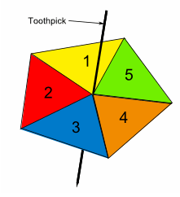
If X represents the number on the edge the spinner lands on, find and interpret the standard deviation.

4. Four fair coins are tossed. If X represents the number of heads, what is the mean of X?

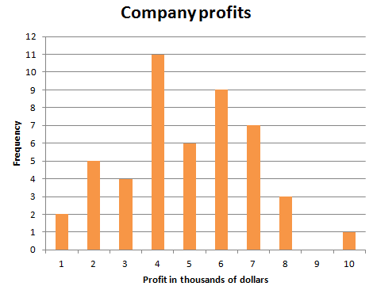
5. The graph shows the monthly profits made by a company over the last 48 months, each rounded to the nearest thousand dollars. Using the frequencies from the graph for predicting future profits for the company, what is the expected value and standard deviation?

STATION #2
1. The probabilities that a randomly selected customer purchases 1, 2, 3, 4, or 5 items at a convenience store are 0.32, 0.12, 0.23, 0.18, and 0.15, respectively.

(a) Draw a histogram for this distribution.

(b) Calculate the mean, standard deviation, median and IQR.

(c) Describe the distribution.

2. Suppose that the mean height of policemen is 70 inches with a standard deviation of 3 inches. If heights of policemen are Normally distributed, find

- The probability that the height of a policeman is no more than 72 inches

- P(X ≥ 66.4)

- The probability that a policeman is between 67 and 71 inches tall

- The probability that a policeman is exactly 71.8 inches tall

- How tall is a policeman who is in the top 20% of heights?

STATION #3
1. Scores on the Mathematics part of the SAT college entrance exam in a recent year had mean 519 and standard deviation 115. Scores on the Verbal part of the SAT had mean 507 and standard deviation 111.
(a) What is the mean of the total SAT score (Math plus Verbal)?

(b) If you can calculate the standard deviation of the total SAT score, do it. If not, explain clearly why you can’t.

2. Grade Point Average (GPA) is often on a 4 point scale (with A = 4, B = 3, and so forth). The probability distribution table below shows the grade (in point scale) and proportion of grades of Statistics 101 students in a recent semester at North Carolina State University. Suppose two NC State students, M and N, are selected at random. Find the mean and standard deviation of the difference in the GPA’s of student M and student N. Assume the random variables are independent.

Grade | 4 | 3 | 2 | 1 | 0
P(Grade) | .26 | .42 | .2 | .1 | .02

3. The scores for the AP Statistics exam for students in Garrett County follow a Normal distribution with a mean score of 2.9 and a standard deviation of 1.1. The scores for students in Cecil County follow a Normal distribution with a mean score of 3.6 and a standard deviation of 1.3. Find the probability that a randomly selected student’s AP Statistics score from Garrett County is larger than a randomly selected student’s AP Statistics score from Cecil County.

