1. Determine whether the distribution represents a probability distribution. If it does not, state why. a) No - Cannot have a negative

|  |  |  |  |  |
| --- | --- | --- | --- | --- |
| X | 3 | 6 | 8 | 12 |
| P(X) | 0.3 | 0.5 | 0.7 | -0.8 |

b) Yes – Equals 1

|  |  |  |  |  |  |
| --- | --- | --- | --- | --- | --- |
| X | 2 | 5 | 6 | 8 | 10 |
| P(X) | 2/11 | 3/11 | 3/11 | 2/11 | 1/11 |

c) No - Equals 1.1

|  |  |  |  |  |
| --- | --- | --- | --- | --- |
| X | 20 | 30 | 40 | 50 |
| P(X) | 0.05 | 0.35 | 0.4 | 0.3 |

2. Construct a probability distribution for the data and draw a graph for the distribution. The probabilities that a student volunteer hosts 1, 2, 3, or 4 prospective first-year students are 0.4, 0.3, 0.2, and 0.1 respectively.

X 1 2 3 4

P(X) 0.4 0.3 0.2 0.1

3. State whether the variable is discrete or continuous.

a) the speed of a jet airplane Continuous

b) The number of cheeseburgers a fast-food restaurant serves each day Discrete

c) The number of people who play the state lottery each day Discrete

4. Construct a probability distribution for drawing a card from a deck of 40 cards consisting of 10 cards numbered 1, 10 cards numbered 2, 15 cards numbered 3, and 5 cards numbered 4.

|  |  |  |  |  |
| --- | --- | --- | --- | --- |
| X | 1 | 2 | 3 | 4 |
| P(X) | 2/8 | 2/8 | 3/8 | 1/8 |

a) P(X< 4) = 7/8 c) P(2 < X < 4) = 5/8 e) P (X = 3) = 3/8

b) P(X <2) = 2/8 d) P(X > 2) = 4/8 = 6/8

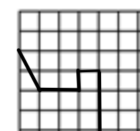5. A density curve is pictured below. Use the distribution

to find the following probabilities.

a) P(X < 1) = 0.3

b) P(X > 2) = 0.5

c) P(X = 3) = 0

1 2 3 4 5 6

d) P(1 < X < 3) = 0.4

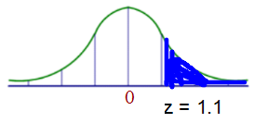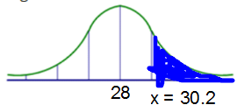6. Each month, an American household generates an average of 28 pound of newspaper for garbage or recycling. Assume the variable is approximately normally distributed and the standard deviation is 2 pounds. If a household is selected at random, find the probability of its generating

a) More than 30.2 pounds per month

P(X > 30.2) = P(Z > (30.2 – 28)/2) = P( Z > 1.1) = 0.1357

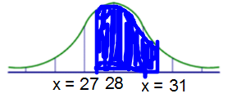The probability that the pounds of newspaper for recycling is more than 30.2 pounds per month is .1357.

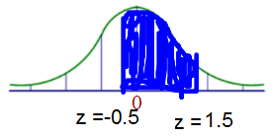 b) Between 27 and 31 pounds per month

P( 27 < X < 31) = P( (27-28)/2 < z < (31 – 28)/2 ) = P ( -0.5 < z < 1.5 ) = 0.6247

The probability that the pounds of newspaper for recycling is between 27 and 31 pounds per month is .6247.

